This research is based upon the following news article, or FactCheck:

<https://www.channel4.com/news/factcheck/factcheck-is-london-really-deadlier-than-new-york>

The article begins with the following statement:

“For the first time in modern history, London’s murder rate is higher than New York’s. At least that’s what was reported last week.

But FactCheck has received new figures from the New York Police Department that suggest otherwise.”

So, once again, here are the snapshots from the article:

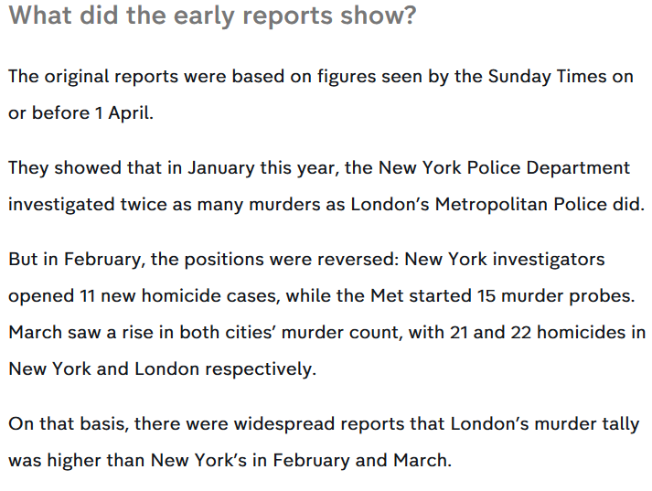

Now, I’m not going to post the full article here, as it’s very lengthy, but the main points are the graphs, as they say a picture says a thousand words, which is helpful in a blog.

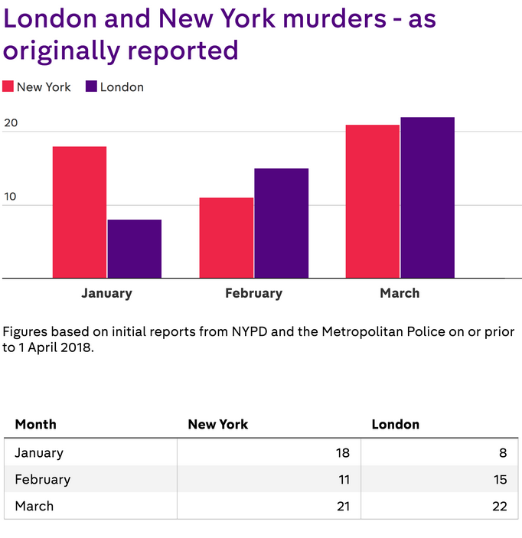

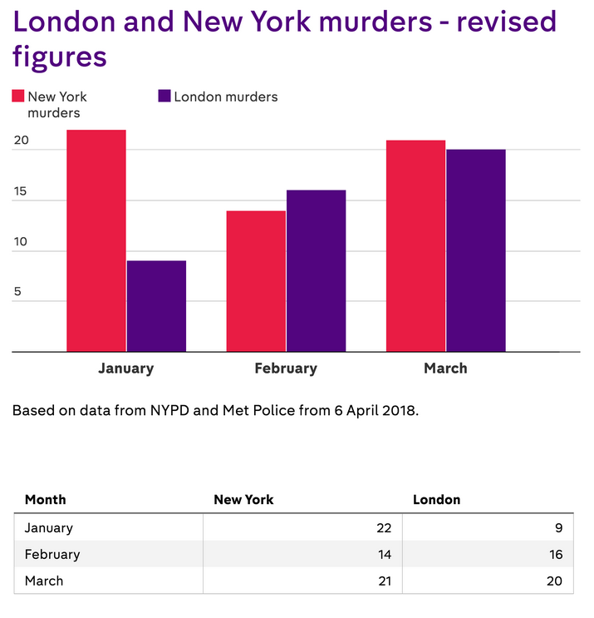

So, for this bit of research, I’m going to look at the figures to determine if the article is true or false.

Now, looking at this actual article, it does say this:

“The original reports were based on figures seen by the Sunday Times on or before 1 April.

They showed that in January this year, the New York Police Department investigated twice as many murders as London’s Metropolitan Police did.

But in February, the positions were reversed: New York investigators opened 11 new homicide cases, while the Met started 15 murder probes. March saw a rise in both cities’ murder count, with 21 and 22 homicides in New York and London respectively.

On that basis, there were widespread reports that London’s murder tally was higher than New York’s in February and March.”

This is for 2018, as the article was actually published on 09 April 2018. So, let’s see what we can find.

So, to start with, I went to the New York Police Department (on the internet, not a trip across the pond):

<https://www1.nyc.gov/site/nypd/index.page>

And there you can look at statistics etc. for crimes committed. There are two main areas to look at here:

One is for the Reports and Statistical Analysis:

<https://www1.nyc.gov/site/nypd/stats/reports-analysis/reports-landing.page>

And for anything related to murders, I looked at this briefly:

<https://www1.nyc.gov/site/nypd/stats/reports-analysis/crime-enf.page>

But this is mainly only for ethnicity of those that committed the crimes, so this isn’t really something that will help my research, so I’ll ignore this area of the site and focus on the other one.

So the second main page is for Crime Statistics:

<https://www1.nyc.gov/site/nypd/stats/crime-statistics/crime-statistics-landing.page>

This looks to be the main area, so in there are various categories, of which we’ll look at in turn, in no particular order. First there is COMPStat 2.0, but using Chrome, Edge and Firefox, all were giving an error, so either its down or it’s only for the police dept. to view, or anyone with specific access.

For each other section, I can find data for all years etc., but I want to look at the dates mentioned in the article:

On or before April 2018, graphs are January to March, so those are the three months I’ll be concentrating on.

The first is the Citywide Crime Statistics, so it’s not split into precincts etc. I looked at the weekly stats, however there is nothing that relates to the graphs etc., as the pdf states it’s for 7/2/2018 (remember, that in the US, they put month before day, as opposed to UK), so this is 02 July 2018 through to 08 July 2018, hence ‘weekly’. No good for me, I’m afraid.

So, in this section we also have a subheading for Incident Level Data. The first link is only up to 2015, but the second ‘Crime incident-level data, current year through most recent full quarter’, is a bit more relevant:

<https://data.cityofnewyork.us/Public-Safety/NYPD-Complaint-Data-Current-YTD/5uac-w243>

Now, this is very big. For instance, looking at the bottom table it states that it’s only showing rows 1-14, and that there are 109543 rows.

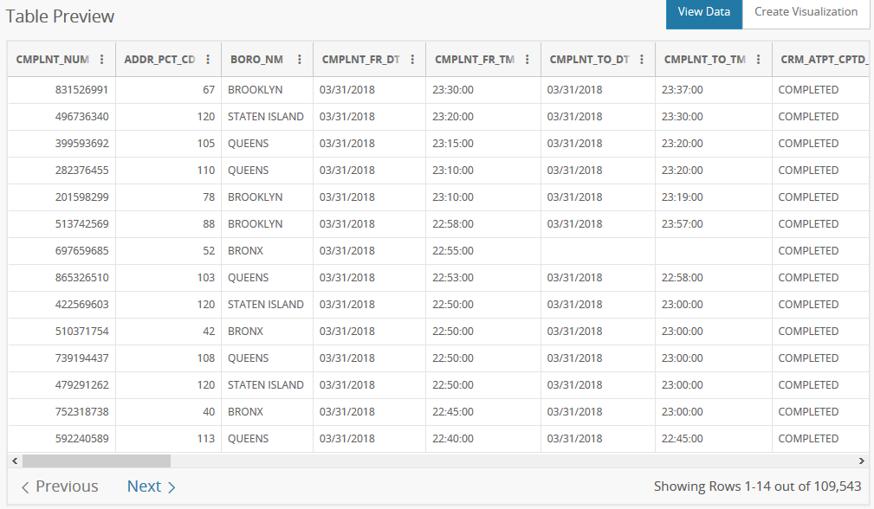

(THIS WAS WHEN I RESEARCHED ORIGINALLY) – screenshots onwards

As you can see on the above picture, there is a button on the top right ‘Create Visualization’. This then opens up into another page, where you can manipulate the data. Now, I originally tried their website out, but it seems you can’t remove columns, and (from what I can see) you can’t move any or sort by a particular entry. So, having to look at via Excel, and as it’s a csv file, you need to separate the fields etc.

Also, the screenshot I gave showing what there was only showed a few columns. There are in fact 35! So, the columns I’ll be looking at are:

CMPLNT_FR_DT - Exact date of occurrence for the reported event

RPT_DT - Date event was reported to police

LAW_CAT_CD - Level of offense: felony, misdemeanour, violation

OFNS_DESC - Description of offense corresponding with key code

A full list of what all the headings are is shown here:

<https://www1.nyc.gov/assets/nypd/downloads/pdf/analysis_and_planning/incident_level_data_footnotes.pdf>

So, as I’m not sure which dates they use for the stats, I’ve looked at both. So, for January to March 2018 for CMPLNT_FR_DT, this is what I found:

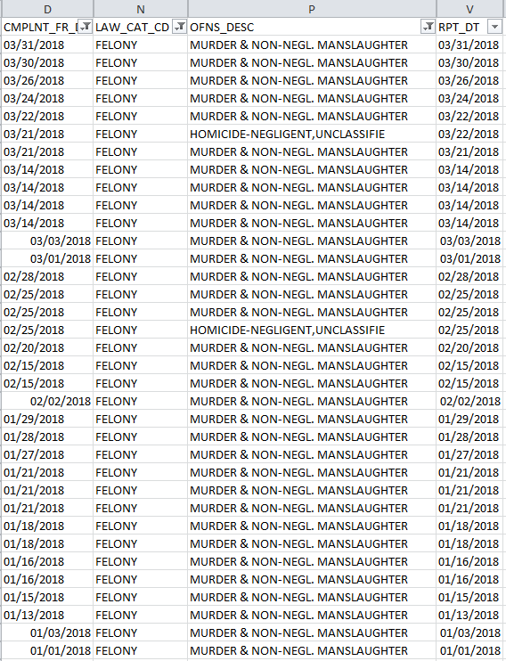

And this equates to:

January – 14, February – 8, March – 13

For RPT_DT this is:

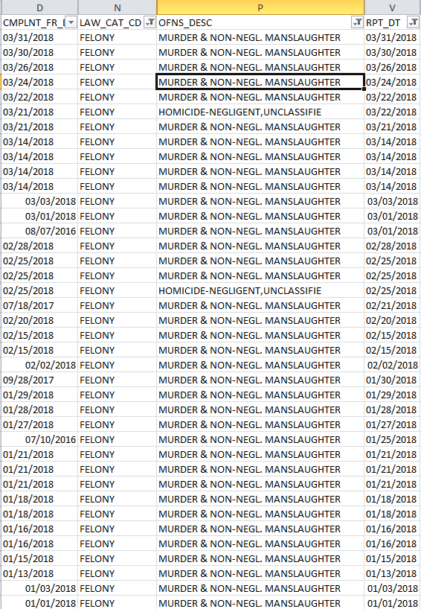

And this equates to:

January – 16, February – 9, March – 14

And the numbers via the news article were:

January – 22, February – 14, March – 21

Hmm, quite a big difference, using either of the columns for the dates.

So, let’s have another look at the webpage, and see if anything else will give meaningful values. Like I mentioned above, I’m looking at specific dates, which is why I chose those two columns to look at.

The next section is called ‘Borough and Precinct Crime Statistics’. Now, these are split into many different reports, as you can imagine, as New York is pretty big. However, these are also weekly, like previously mentioned, so this isn’t something I can use. And the final is ‘Historical New York City Crime Data’, which unfortunately only goes up to 2017.

Now, I can hypothesise a few things. I’m looking at murder rate (homicide). But I wonder if they added ‘dangerous weapons’ into the mix? Not sure, so let’s just take a look. But I would say beforehand, it shouldn’t, as you can have a weapon, but not use it.

So, looking at this, in the section of Felony, as that is a serious crime, I found about 875 records for those dates, so I would assume that weapons are not included in the numbers.

But my confusion is where the numbers from the article come from, as they’re not on New York City Police website.

So, let’s move on and look at the met police in London

Now, we have a website that’s a lot easier to work with:

<https://www.met.police.uk/sd/stats-and-data/met/crime-data-dashboard/>

So, with this page, we can select the dates to/from and the crime. But the funny (well, in the case of labelling) thing about this dashboard: murder is under Minor not Major crime. I would think its very major, taking a life, but looks like for example, fraud is far worse. Maybe for the taxman…

Anyway, back to the main reason we’re here. The pictures below only show a partial image of the map, but if you go to the link above, it shows the full map.

January - 9

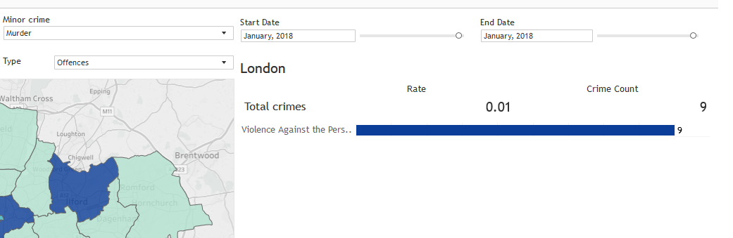

February – 18

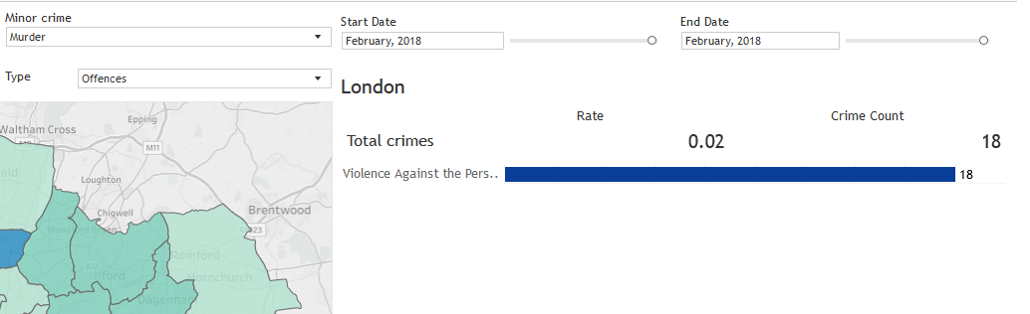

March – 18

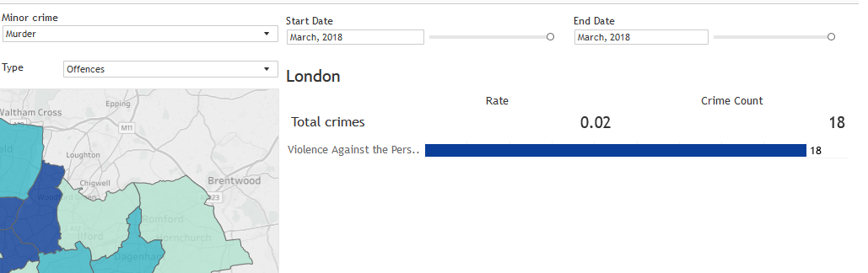

And the numbers via the news article were:

January – 9, February – 16, March – 20

So, whilst these numbers don’t match the article, they’re a lot closer than the NYPD’s.

Let’s pop that in a graph, to show, for ease of use. I’ve taken the highest values for New York, calculated from the RPT_DT.

Here is the original article numbers:

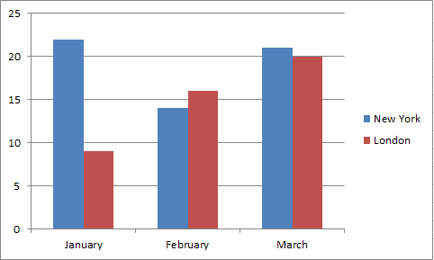

And the values obtained from the records that are for the public:

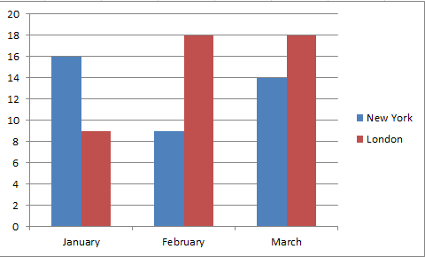

Now, looking at this, based on my findings, here is my conclusion.

The article itself is false, the article stated:

“For the first time in modern history, London’s murder rate is higher than New York’s. At least that’s what was reported last week.

But FactCheck has received new figures from the New York Police Department that suggest otherwise.”

Based on the values that I obtained from the New York Police Department and the Met Police in London websites, yes, in January it was lower, but not in February or March. It was significantly higher.

What values did the article use, and where from? It states from the NYPD, but not from what I can find. If there are additional values (and bear in mind I’m researching this in July/August 2018), where are they, as I couldn’t find them? If the values the article used were 100% correct, then the NYPD needs to update their records. But then we only have the article’s word for it.

This was an interesting bit of research, of which there was some number crunching, but not a lot. Also, finding out the crime for NYPD and London was very interesting, as I glanced at many of the crimes, as many would. So, I recommend having a look at their dashboards.

As always, thank you for reading this, and if you have any comments, please post away ☺