So, for this bit of research, I’m not looking at a news article, but it’s something that was mentioned in a YouTube clip. It was regarding a civil case, and I won’t be linking it here, but there was something in the video that caught my attention, and I want to find out if what they said is true or not.

So, what is it? Well, basically it was this:

When you’re going to court, they bring out the case management files and there is a declaration box which you must sign before. Only two people can sign this: the defendant (yourself) or your solicitor. Without a signature, you can’t be charged or sent to prison.

So, that’s what I want to look at, and see if it’s true or not. And if it is, and someone has represented themselves but not signed this and was sent to prison…

Anyway, let’s see what we can find ☺

So, firstly, what is Case Management? Well, as you can probably guess there are numerous places that explain but I’m after an actual ‘law’ website, as opposed to a random website.

So, in Wikipedia, it states

“The terms legal case management (LCM) or matter management refer to a subset of law practice management and cover a range of approaches and technologies used by law firms and courts to leverage knowledge and methodologies for managing the life cycle of a case or matter more effectively. [1] Generally, the terms refer to the sophisticated information management and workflow practices that are tailored to meet the legal field's specific needs and requirements.”

<https://en.wikipedia.org/wiki/Legal_case_management>

So, it looks like that it’s actually the approach taken by law firms. But I want to find the actual legal forms, so I manged to find some on the UK Justice website:

<http://www.justice.gov.uk/courts/procedure-rules/criminal/forms>

Now, there are a few forms in here, but I’ll just look at the main ones that are related to this research.

Part 3 of the webpage is the Case Management. The first is the Preparation for Trial in a Magistrates’ Court form:

<http://www.justice.gov.uk/courts/procedure-rules/criminal/docs/october-2015/cm001england-eng.pdf>

And a snapshot is here:

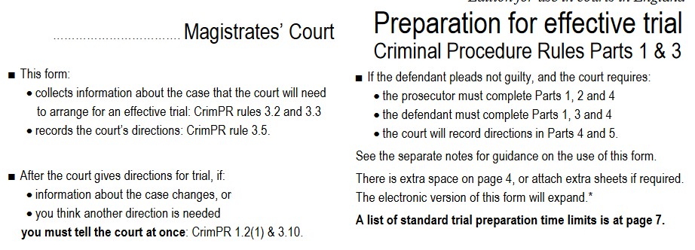

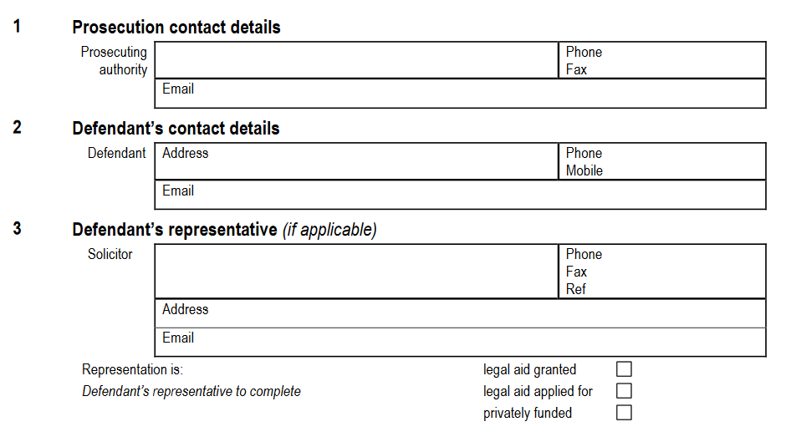

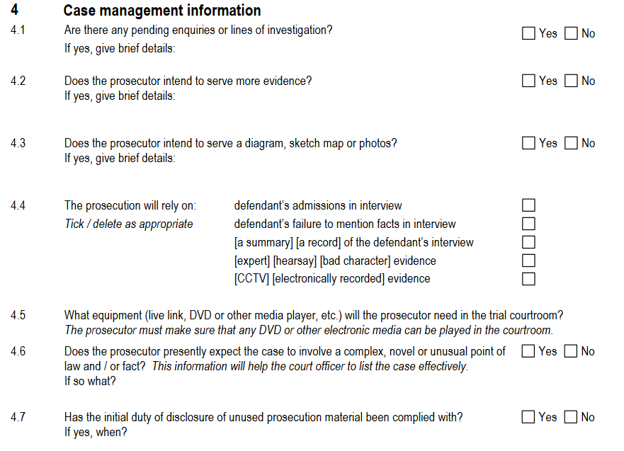

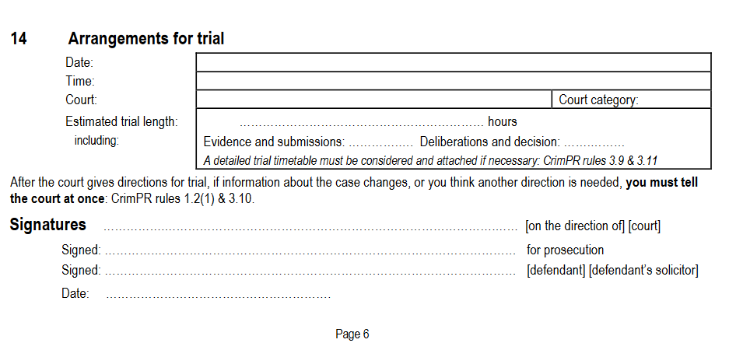

Which actually looks like the solicitor, and I’m only looking at if the defendant pleads Not Guilty. So, it appears that this is filled in by the solicitor. But what happens if you defend yourself? Well, let’s see what the rest of the forms show for now.

In the same list for the Magistrates Courts forms, there is also a guidance booklet:

<http://www.justice.gov.uk/courts/procedure-rules/criminal/docs/october-2015/cm001-notes-eng.pdf>

Some parts I’ve shown here:

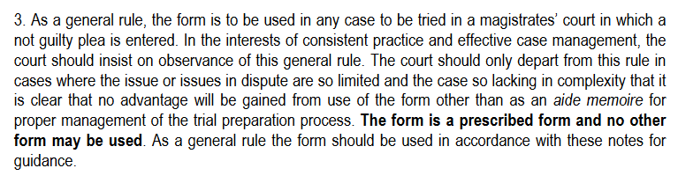

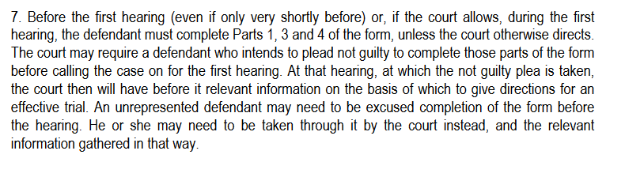

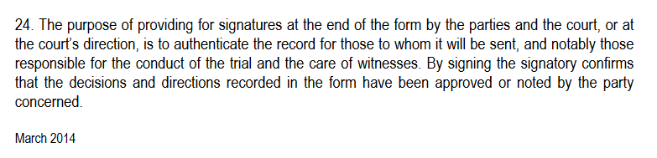

So, the final screenshot explains about the signatures. But what it doesn’t say is, what happens if you don’t sign it. You can complete the form in court at the time of the trial, if you’re defending yourself, as the solicitor won’t be there to have signed it.

So, remember, the parts I’m looking at, is do you both have to sign it (if you have a solicitor) or is the solicitor’s binding over yours? If you’re defending yourself, what happens if you don’t sign it?

Now, the rules themselves take some reading, and I’m not a lawyer, so I’m trying to look at them in a sort of laymen’s terms. So, for instance, this is a list of the rules:

<http://www.justice.gov.uk/courts/procedure-rules/criminal/rulesmenu-2015>

And looking into a few, I’m highlighting areas with regarding documents, or what I think may be deemed a document.

<http://www.justice.gov.uk/courts/procedure-rules/criminal/docs/2015/crim-proc-rules-2015-part-03.pdf>

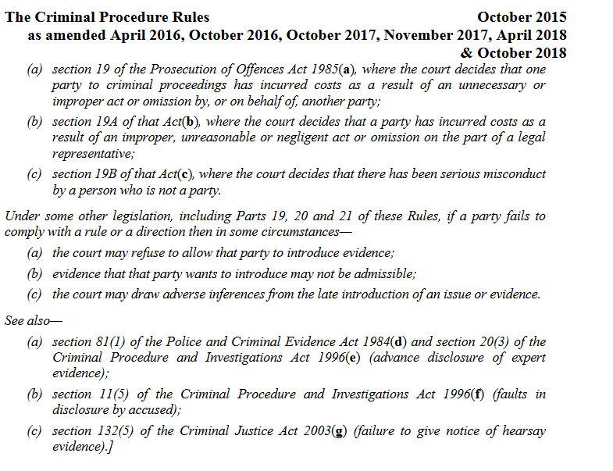

So, if a party fails to comply with the rules, parts 19-21, then the evidence may be admissible, or allow as evidence. Not sure if that relates to a document or not. Ah, it appears that it relates to evidence, not the actual case files.

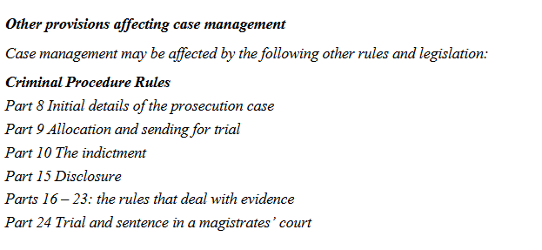

Ah, finally something about the actual forms. By the end of this, I’ll be so up on court proceedings, I may apply for a job ha-ha.

Anyhoo, here it is:

<http://www.justice.gov.uk/courts/procedure-rules/criminal/docs/2015/crim-proc-rules-2015-part-05.pdf>

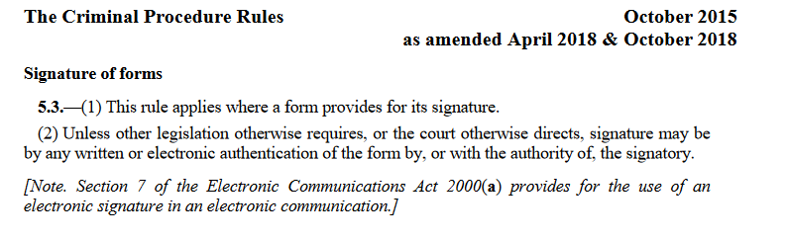

Er, well, in fact it isn’t. Majority of that section is about wanting information on a case etc. ☹

<http://www.justice.gov.uk/courts/procedure-rules/criminal/docs/2015/crim-proc-rules-2015-part-16.pdf>

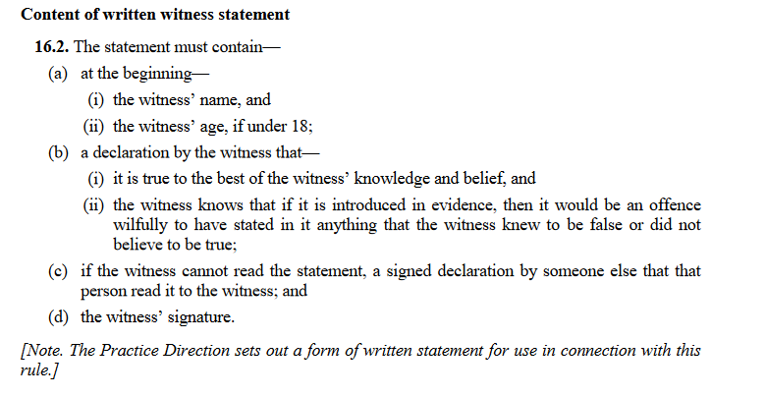

Unfortunately, I’ve been all through the rules of court proceedings, and can’t see anything that states that the case management files are needed to sentence. But, from what I can gather, in the screenshots I’ve posted from the rules I’ve linked, is that you have to sign the documents either before the court case, or if defending yourself and enter a plea of not guilty, at the time of the hearing, with the aid of the prosecutor and judge. And it says you have to sign.

Contempt of court is here:

<http://www.justice.gov.uk/courts/procedure-rules/criminal/docs/2015/crim-proc-rules-2015-part-48.pdf>

But the basics are:

Obstructive, disruptive, insulting, intimidating, affecting court proceedings, refusing to give evidence, recording.

So, is not signing the document contempt of court, as you’re affecting the court proceedings?

Ah, now this is very interesting. Found this when trying to figure out contempt of court for not signing:

<https://www.justice.gov.uk/courts/procedure-rules/family/parts/part_17>

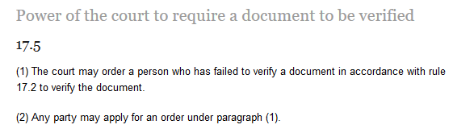

So, the court can order you to sign it, and I’m assuming if you don’t comply, you’ll be in contempt of court. Curious if anyone has stood their ground on this one.

So, from what I can gather, yes there are documents that need to be signed for the court, and these are called the case management files. They can be signed by either you or your solicitor. If you have a solicitor representing you, then if you refuse to sign it, or are unsure, they will automatically sign it. But if you represent yourself, and don’t sign it at the time, in court they will ask you to complete and sign it. But if you don’t, the judge can order you to sign it, and if you still don’t, you’ll probably be in contempt of court as you’re disrupting the court proceedings.

In the case of the clip I saw, maybe due to the few times the contempt of court times, and the fact it was a motoring offense (no insurance), the court decided not to go ahead with the case, due to time etc. Who knows? But in the grand scheme of things, you’ll probably be best signing, and if you’re really guilty, don’t utter a single word in your ‘interview’, so that they can’t use anything, not even a No Comment, against you \*wink\*