<https://www.express.co.uk/news/world/929123/gender-pay-gap-eu-report-statistics-eurostat>

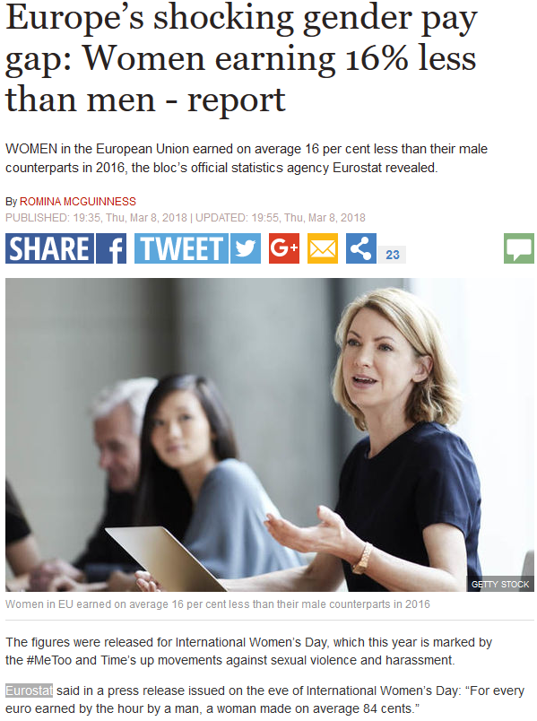



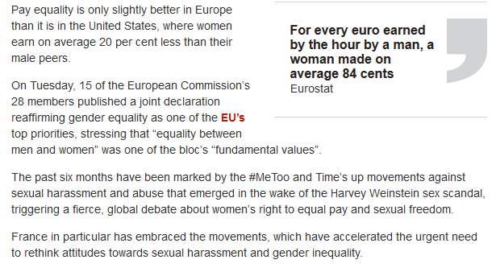

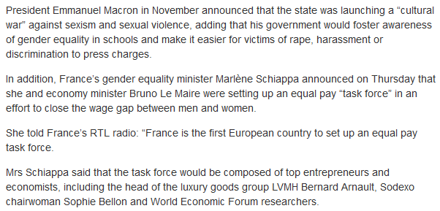

--

<http://ec.europa.eu/eurostat/web/labour-market/earnings>

The unadjusted Gender Pay Gap (GPG) represents the difference between average gross hourly earnings of male paid employees and of female paid employees as a percentage of average gross hourly earnings of male paid employees. The GPG data is based on the methodology of the Structure of Earnings Survey (SES). GPG data are released approximately 12 months after the end of the reference period.

This is the website stated in the article.

Now, the main question is, is the pay gap 16% for the exact same jobs that men do vs women, or just as an overall amount etc.

Onto the research:

Let’s start with the Eurostat, as this is the company that is leading this issue.

This is the Main Tables:

<http://ec.europa.eu/eurostat/web/labour-market/earnings/main-tables>

And this is the Database:

<http://ec.europa.eu/eurostat/web/labour-market/earnings/database>

So, onto the tables. In there, we have the following:

|  |  |
| --- | --- |
| Average gross annual earnings in industry and services, by sex (tps00175) |  |

Viewing this table, we see that there is only data in there for 2008 to 2011. This is a snapshot from the actual link:

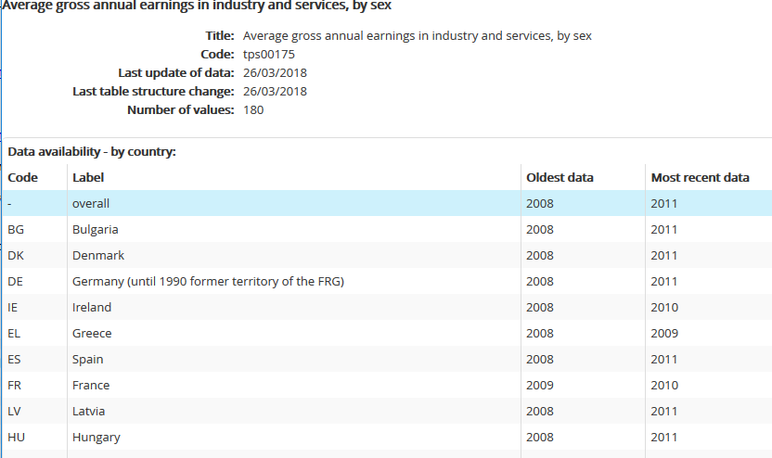

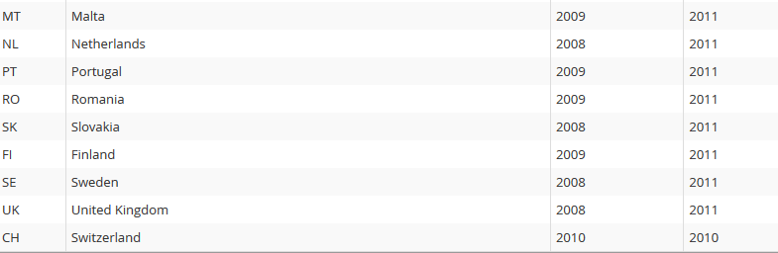

But as you can easily spot, although this was updated 26/03/2018, the most recent data for each country is 2009-2011.

And actually viewing the file in Excel, we get the following:

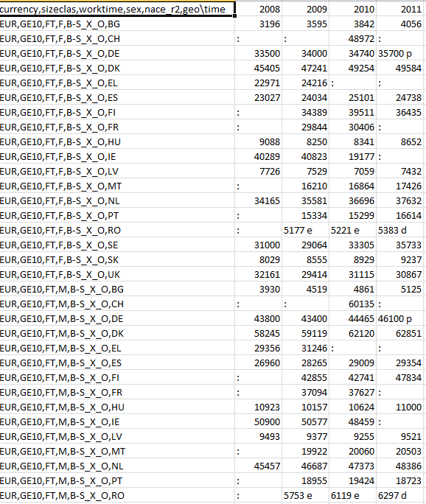

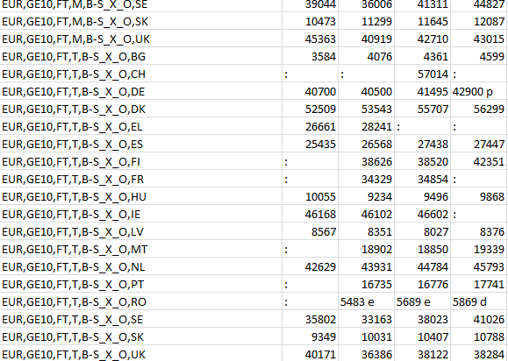

Now, as you can very well see, there is nothing in there about particular jobs. So, a bricklayer working outside for all hours compared to a cleaner working the same hours inside is not shown. Not a direct comparison at all.

But yes, you can ‘see a difference’: Looking at only 2011 for each country (MvsF), we get the following, but it’s not something you can use to say there is a gap:

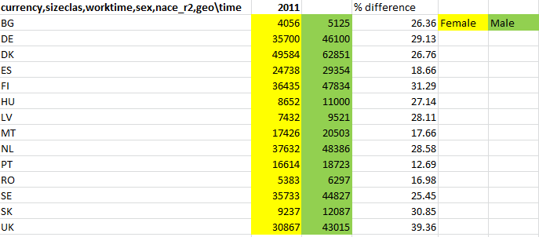

But like I said, a gap yes, but a comparative gap, no.

So, let’s see what else there is that may show something tangible.

Looking at the same place we obtained the Average Earnings, there is this one:

Gender pay gap in unadjusted form (sdg_05_20)

Again, we can look at the link itself, and see what the snapshot shows. Now, this was updated in 11 April 2018, and the picture below shows recent data 2016. This is the latest date for all of the countries in the link:

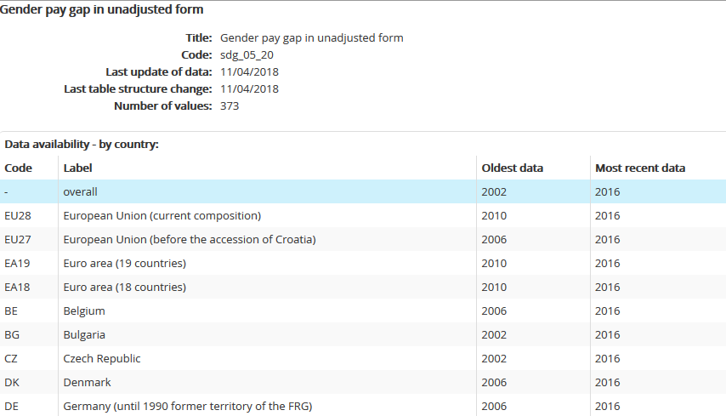

So, let’s get that into Excel form for viewing. It’s a bit large across the columns, as it’s from 2002 to 2016, but hopefully you can see this:

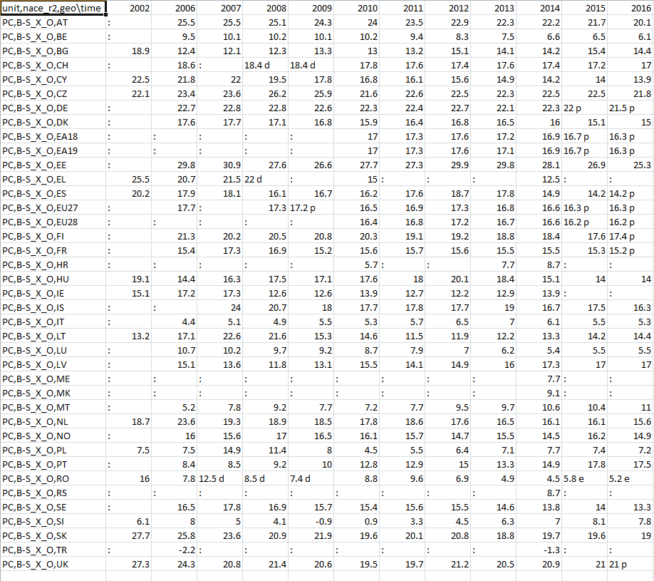

Now this is where it gets confusing. So, the first link is the average earnings for each country for a male/female. So, we looked at the values for 2011 previously, and calculated the difference. But looking at the second link, we can see there is a difference between the two.

So, remember that the first link gave it in the full format, and I calculated using Excel, the difference. I used the calculation:

(Male-female)/female x 100

So, for the country BG (Belgium) for 2011, I originally got 26.36 differences. But in the above ‘official’ spreadsheet, it is 13.2. Well, it’s lower, but curious where they got these values from.

I’ve created a comparison between the two spreadsheets (mine calculated and the official):

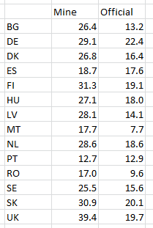

So, my findings so far on no particular type of job, shows it to be worse than stated (mostly), with some being the same. Anyway, let’s carry on, as we really need to see the comparisons with regards to job roles.

The third link in the webpage is regarding Minimum Wages:

Minimum wages (tps00155)

Which again shows it was updated in 2018, but recent data is 2015. Not really useful to determine the wage gap, but interesting none the less.

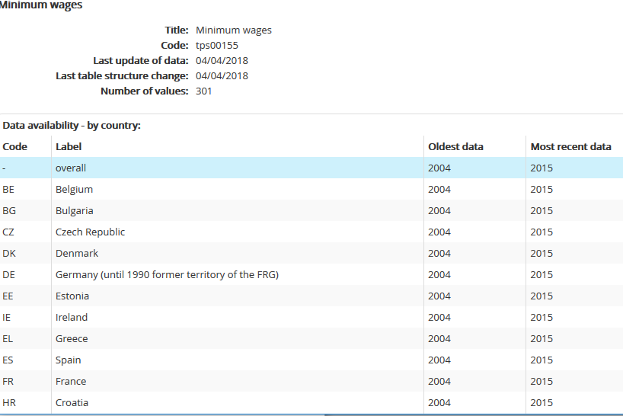

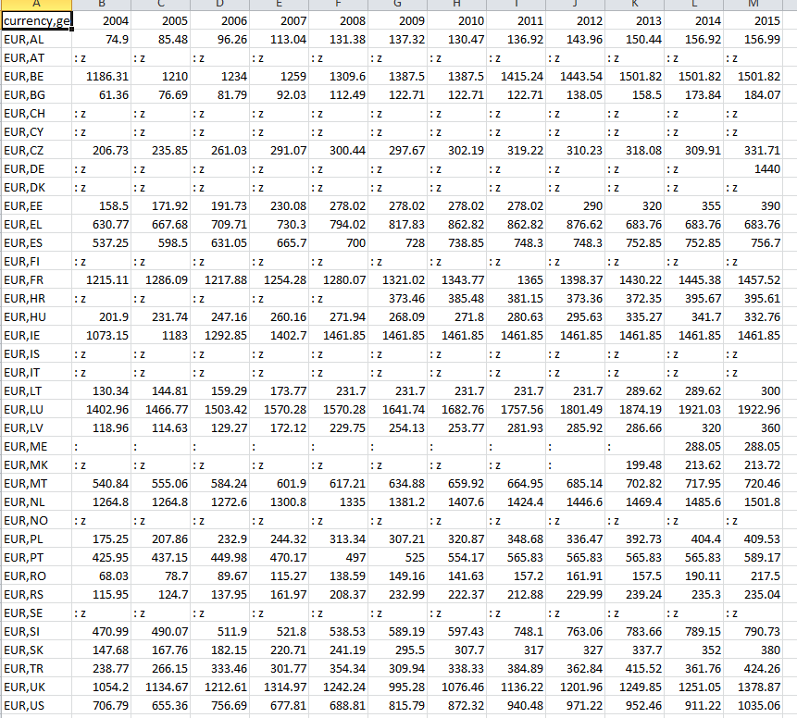

So, we can go off on a tangent for a brief spell. Many countries boast that minimum wage is increasing over the years. I’ll look at the countries in the above that have 2 or more year’s data. Also, from what you can deduce, this doesn’t seem to be minimum pay, in terms of hourly, but more in terms of the yearly.

I’ve created a colour code, which is for ease of viewing:

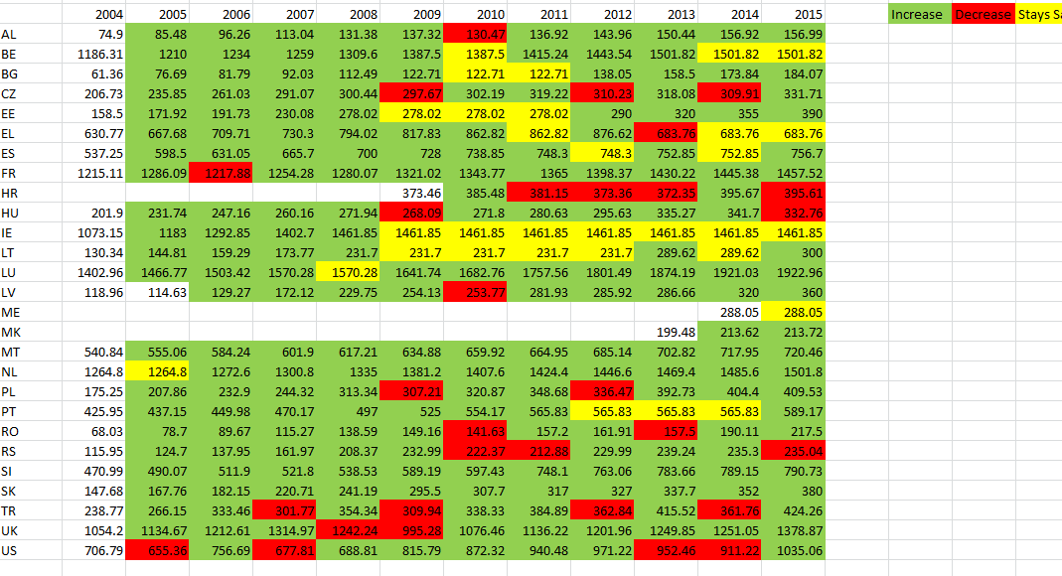

So, as you can see, some countries have fluctuations, probably due to inflation etc. A few have a great increase which is great. But at least you can see how well each country is doing. I’ve done a small amount of calculation to show what the difference from 2004 (or next earliest date) to 2015 is, to see how well each country has performed. So, this will show a better way of reading the data, as the above is on currency, not percentage.

The calculation I used was:

(2015 date – Earliest date)/Earliest date

Then, pressed the % button in Excel.

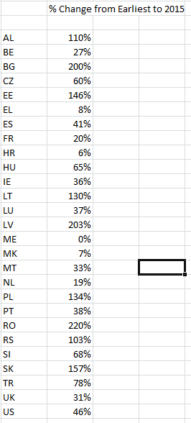

So, from this, you can see which country has increased bigtime since the records for that country began, versus some others.

Anyway, back to the pay gap part. From the above, we’ve so far found out that there is a gap between male/female, but not for a specific job, and no details about hours etc. that it’s related. Let’s see what the other links from the site have.

We have the Database to look at:

<http://ec.europa.eu/eurostat/web/labour-market/earnings/database>

Going from top to bottom, let’s see if anything sheds any light on the 16% gap that is reported in the news.

The first is Earnings, and this has 5 databases linked to it:

|  |  |
| --- | --- |
| 1. Annual net earnings (earn_nt_net) |  |

Looking at the details from this, there isn’t anything new since 2016:

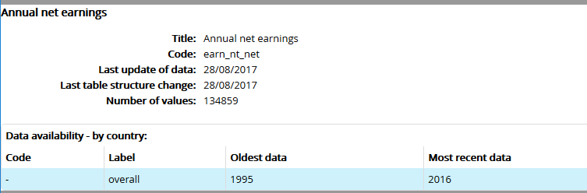

Now, opening in Excel gives a massive amount of numbers. Although this is useful to look at, I feel this will take me off course. You can open it up in the browser, and it basically shows the earnings per country based on many criteria’s, none of which are male vs female:

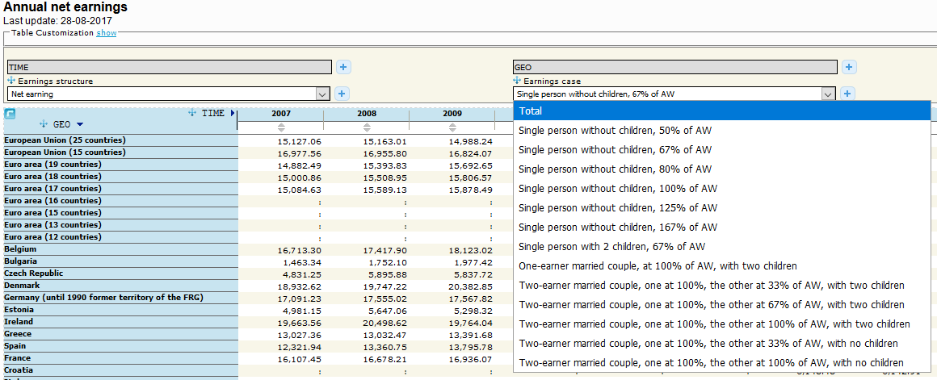

Tax rate on low wage earners: Tax wedge on labour costs (earn_nt_taxwedge)

Tax rate (earn_nt_taxrate)

Tax rate on low wage earners - Unemployment trap (earn_nt_unemtrp)

Tax rate on low wage earners - Low wage trap (earn_nt_lowwtrp

The above I’m not going to look at in detail, as like I say, I feel this will take us off into a tangent.

-

But the second database is interesting: Structure of earnings survey

There are 3 here: hourly, monthly, yearly. Opening in Excel doesn’t show anything tangible, but if you open within the site, you can get various options.

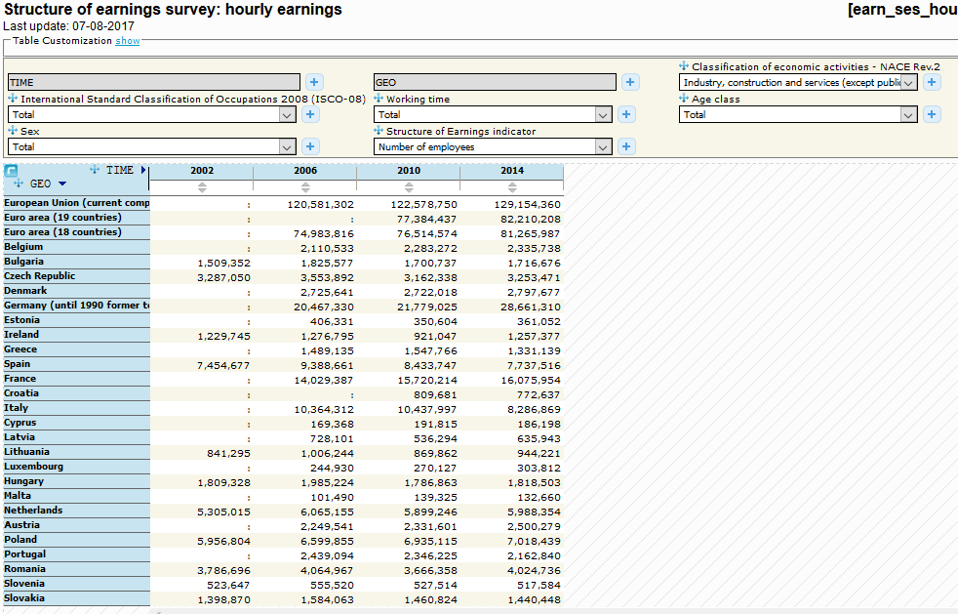

So, as you can see from the above, there are different industries. However, there are only 4 when you look further, which is disappointing. But you can show between male/female for each type. It’s advisable to open the interactive (above) as the Excel is a lot of numbers. So, what I will do for the purpose of this research, is open for male and female each, for’ industry and construction’ and ‘Education’ to narrow it down, and save my poor fingers from typing. I’ll post all snapshots, so it’s easier to see at a glance, then just numbers on a sheet.

Firstly, male for construction:

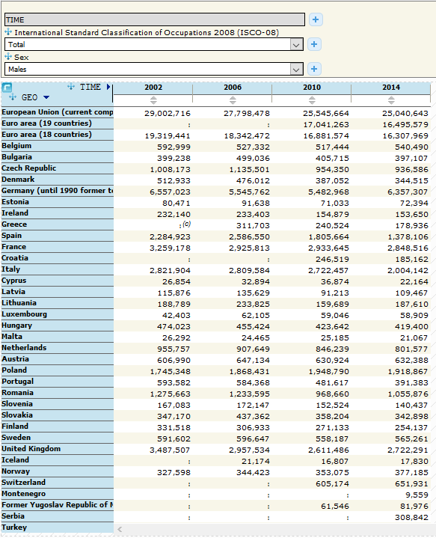

Next, female for construction:

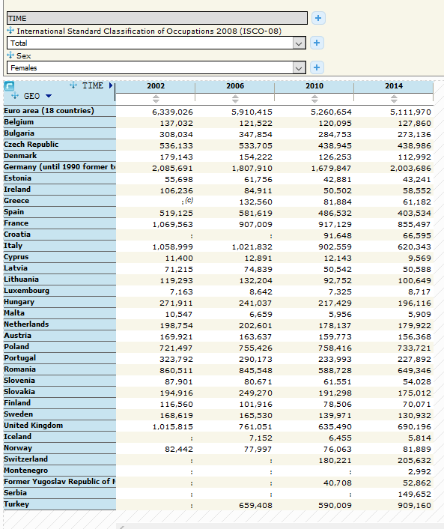

Next, male for education:

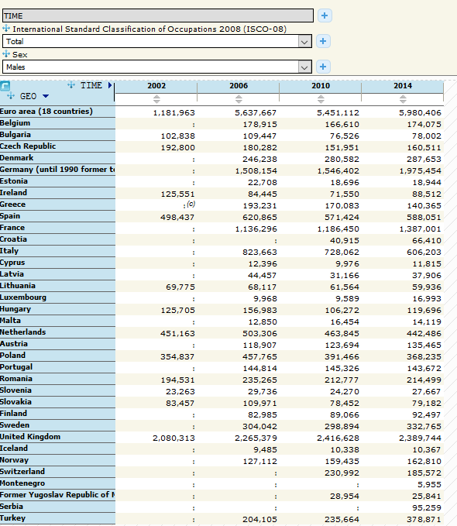

And female for education:

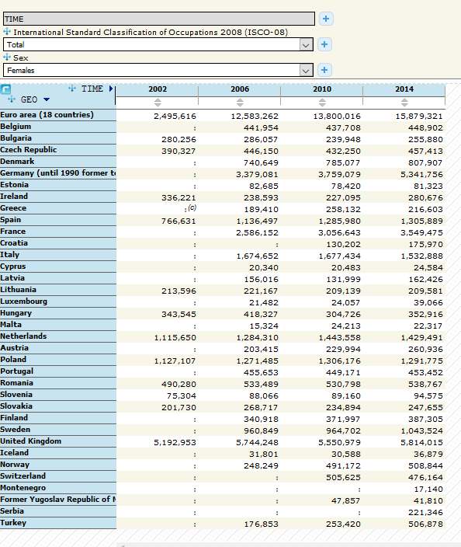

So, I’m just going to focus on 2014 (yep, latest values are 2014 once again, even though updated 2017). Will type into Excel, and calculate difference between male/female for each of the industries above.

Now, it is actually interesting when you look at both in Excel. So, firstly the difference in construction between men and women:

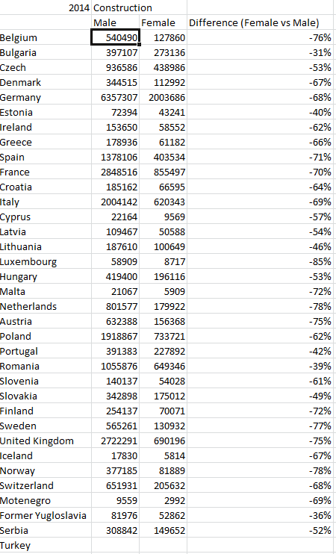

Yep, quite a large gap for women pay versus men, hence I can see the reason for the actual article. But let’s have a look at the education:

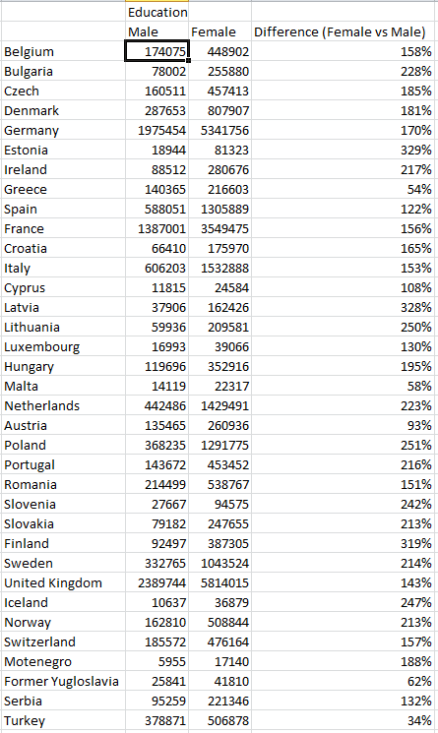

But this is the other way round. It shows that women actually get paid more than men in education, social services etc.

Now, just to pause here, as there is a lot of info that I’ve shown above, so let’s just get our head round a few things.

Firstly, the original article said that there was a 16% pay gap between men and women, and that from the headline; you would assume that is for all sectors, in all countries, no matter what the job was. From what I have found (eventually), is its dependent on the actual job. I’m not being sexist, but construction is mainly male dominated, hence the reason why men get paid more than women.

But education, social care etc. when lumped together seems to be a female dominated area, especially in social care. Hence the reason why men get paid a lot less, due to averages etc.

Without straying off the path too much, as the website I’m getting this data from has so much information, lets concentrate on the main issue, and see if we can narrow it down a bit more.

But that’s the thing; I can’t narrow it down any further. Sure, I can show the Gender Pay Gap in unadjusted form:

Gender pay gap in unadjusted form by NACE Rev. 2 activity - structure of earnings survey methodology (earn_gr_gpgr2)

Which was updated on 27 Feb 2018, but data only up to 2016, which for the UK (where the main news article is about), it’s actually 13% in 2016. Not great I admit, but not 16%. But, it’s a few industries again:

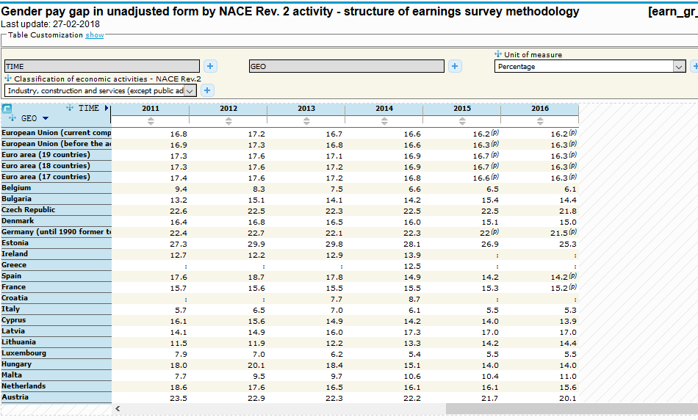

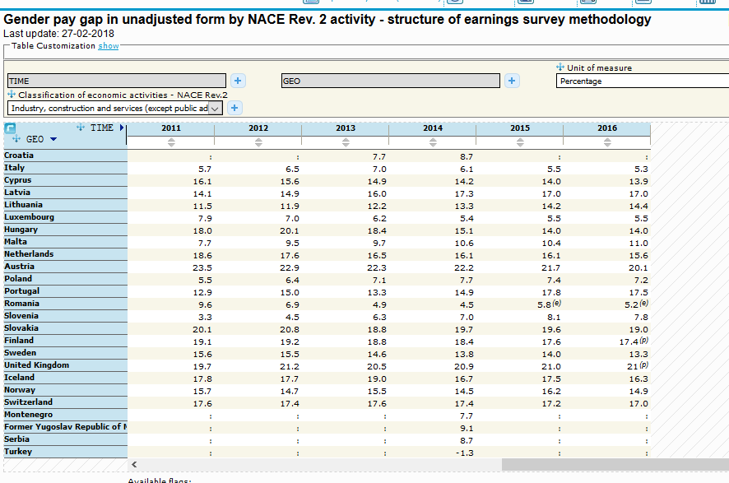

And it’s actually just these:

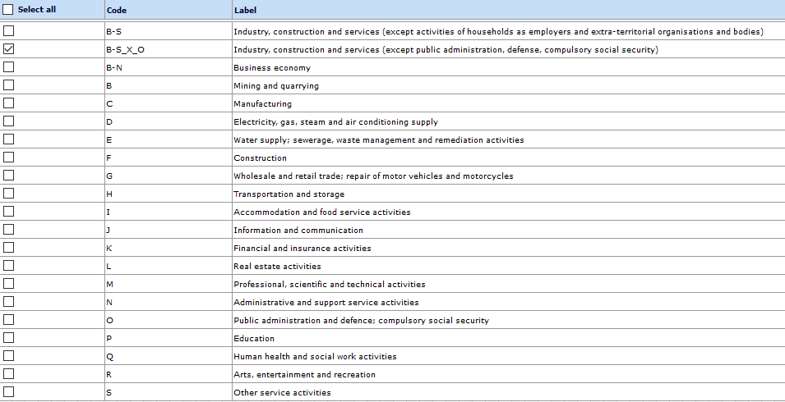

Not the full spectrum of jobs out there. But there definitely is a gap, quite a large one once you delve into it all. It’s just a shame we can’t look at all the codes that are available:

[http://ec.europa.eu/eurostat/ramon/nomenclatures/index.cfm](http://ec.europa.eu/eurostat/ramon/nomenclatures/index.cfm?TargetUrl=ACT_OTH_CLS_DLD&StrNom=CL_ISCO88C&StrFormat=HTML&StrLanguageCode=EN)

As you can see from the above link, it goes into even more depth: Writers, librarians, astrologers etc.

So, my conclusion is as follows. Without going into even more depth so I’ll be deeper than any human has been before, I’ll draw up my findings based on what I have discovered.

Yes, there is a pay gap. We can only speculate that its 16%, as all the databases I found on the EU website only go up to 2014/2016 and nothing after, even though it may have been updated in 2018. It also depends on the industries that the men/women are involved in. Plus, and this is a strong factor, it doesn’t seem to take into account many other factors:

Length of service - not being ageist, if that is even a word, but if someone has been in a position for 10 years (say male) and a woman has been in the exact same position for 2 years, then you would assume that the 10 years will be on more money. Works both ways (women vs men).

Type of position – so, say it’s an admin job. There are countless versions of this, ranging from admin of the CEO, to an admin of an office with countless others there. One will be paid more than the other, due to duties, accountability, etc.

Grades – In many jobs, you can have different grades, and within each grade, there may be increment pay scales. So, a grade 1 in say Lab Assistant will be on less than a grade 4. But in grade 4, you can have someone just promoted, so on the base salary, and someone that has performed well, not enough for the next grade, but enough for a small pay rise.

These are the factors that need to be considered. Now, and I agree, that all should be paid the same depending on the grade etc. as stated above, whether male/female. But to say that a woman on say grade 2 has to be paid the same as a man on grade 3, means that you may as well throw any recognition/promotion down the drain. Add to that the fact if there is none of this, where is the incentive to do more?

But here’s a train of thought that may happen in the wake of all this: Women will get paid the same as men. How? Well, say that you have a working couple, both are in the same industry, but the man is on 20,0000 and the woman 18,000 (grade etc. ignored). Then someone in authority realises that they can’t bump up the women’s pay, as he’d go bankrupt. So, let’s reduce the males to the same as females. That way, there is no pay gap, and he saves money. That couple now will have less income etc.

Not saying that the pay gap is a good thing to have, not by any stretch. Just a case of think of business, and they are in to make money. To push all pay up, they would lose out. But to reduce so all the same, they’re not breaking laws (if they make it one), and the pay gap disappears.

Anyway, please feel free to have a look at the databases; they may be updated in due course.