For this bit of research, I’m going to be looking at the ‘evidence’ that Iran was behind the attack on the oil tankers in the Gulf earlier in 2019. I’ll be looking at the actual video, pictures etc. from the direct source, as well as images from the media. Bear in mind, as this happened in the middle of the ocean, and there aren’t many people swimming by with their phones, I won’t waste time looking for images on social media, unless it’s from a news outlet.
So, with this in mind, let’s begin.
The actual attack in the Gulf involved oil tankers, occurred on the 13 June 2019. Two oil tankers were damaged by explosions in the Gulf of Oman. One was on tanker Front Altair carrying 75,000 tonnes of naphtha. The other was on tanker Kokuka Courageous.
Now, I’m not going to look at the wordy parts in the news articles out there, but images, video (and occasional words when they explain where it was in relation to places) etc.
So, let’s look at the footage. The official site here these all came from, and was either distributed to news outlets, or were allowed to use their footage, was U.S. Central Command:
https://www.centcom.mil/
And the actual video:
https://www.centcom.mil/MEDIA/VIDEO-AND-IMAGERY/VIDEOS/videoid/689676/
And the wording by the video is this:
“Unexploded Limpet Mine Removed from M/T Kokuka Courageous in the Gulf of Oman
U.S. Central Command Public Affairs
June 13, 2019 | 1:39
U.S. Naval Forces in the region received two separate distress calls at 6:12 a.m. local time from the motor tanker (M/T) Altair and a second one at 7a.m. local time from the M/T Kokuka Courageous.
Both vessels were in international waters in the Gulf of Oman approximately 10 nautical miles apart at the time of the distress calls. USS Bainbridge was approximately 40 nautical miles away from the M/T Altair at the time of the attack, and immediately began closing the distance.
At 8:09 a.m. local time a U.S. aircraft observed an IRGC Hendijan class patrol boat and multiple IRGC fast attack craft/fast inshore attack craft (FAC/FIAC) in the vicinity of the M/T Altair.
At 9:12 a.m. local time a U.S. aircraft observes the FAC/FIAC pull a raft from the M/T Altair from the water.
At 9:26 a.m. local time the Iranians requested that the motor vessel Hyundai Dubai, which had rescued the sailors from the M/T Altair, to turn the crew over to the Iranian FIACs. The motor vessel Hyundai Dubai complied with the request and transferred the crew of the M/T Altair to the Iranian FIACs.
At 11:05 a.m. local time USS Bainbridge approaches the Dutch tug Coastal Ace, which had rescued the crew of twenty-one sailors from the M/T Kokuka Courageous who had abandoned their ship after discovering a probable unexploded limpet mine on their hull following an initial explosion.
While the Hendijan patrol boat appeared to attempt to get to the tug Coastal Ace before USS Bainbridge, the mariners were rescued by USS Bainbridge at the request of the master of the M/T Kokuka Courageous. The rescued sailors are currently aboard USS Bainbridge.
At 4:10 p.m. local time an IRGC Gashti Class patrol boat approached the M/T Kokuka Courageous and was observed and recorded removing the unexploded limpet mine from the M/T Kokuka Courageous (video attached).
The U.S. and our partners in the region will take all necessary measures to defend ourselves and our interests. Today's attacks are a clear threat to international freedom of navigation and freedom of commerce.
The U.S. and the international community, stand ready to defend our interests, including the freedom of navigation.
The United States has no interest in engaging in a new conflict in the Middle East. However, we will defend our interests.
U.S. Central Command Statement on June 13 Limpet Mine Attack in the Gulf of Oman, attributable to Capt. Bill Urban, Lead Spokesman for U.S. Central Command.”
We’ll get back to this description soon. Now, onto the video. Like I say, this is the official video, not from a new outlet.
(I’ve recorded it fully in my actual video, both in the website size, and full screen).
The one thing I will do here is post a snapshot:
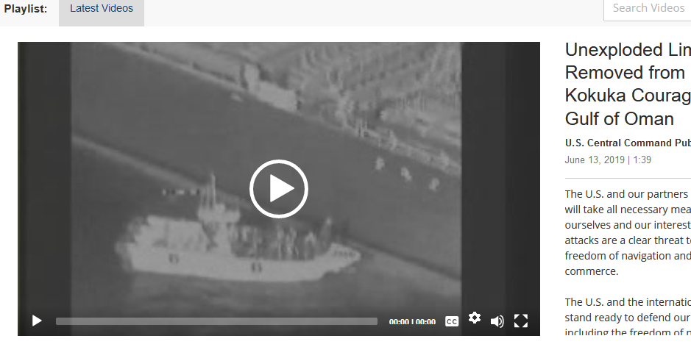
And one where it was playing:
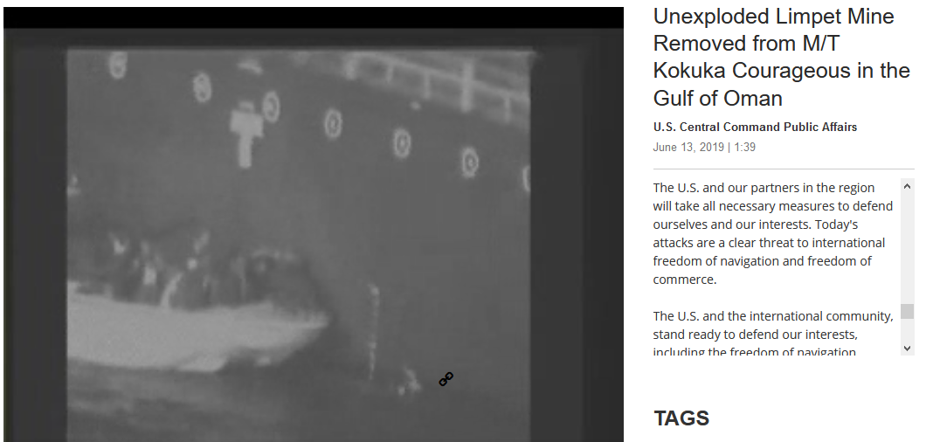

Now, there is a reason why I took the stills. Nothing to do with the tanker, boat, water but the actual image.
Have a look at this new website:
https://www.euronews.com/2019/06/17/us-military-releases-new-images-from-oil-tanker-attacks
And the image they have as the thumbnail before you click play (and nope, the video doesn’t show the thumbnail image stuff):
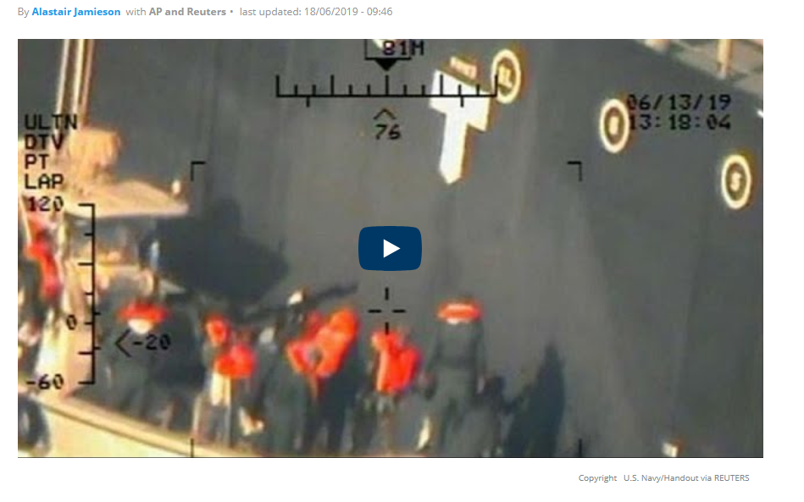
Where have those lines, numbers etc. that are showing the fact it was taken 81M away, on the 06/13/19 (for the UK people, that’s 13 June 19), at 13:18:04 come from? They’re not on the original video direct from the U.S Central Command. If they are on there originally, why remove them? Surely that is the proof that it happened at so-and-so time/date?
We’ll come back to that in a bit as well.
So, what else has the official site got? Well, only one image:
https://www.centcom.mil/MEDIA/IMAGERY/igphoto/2002145928/
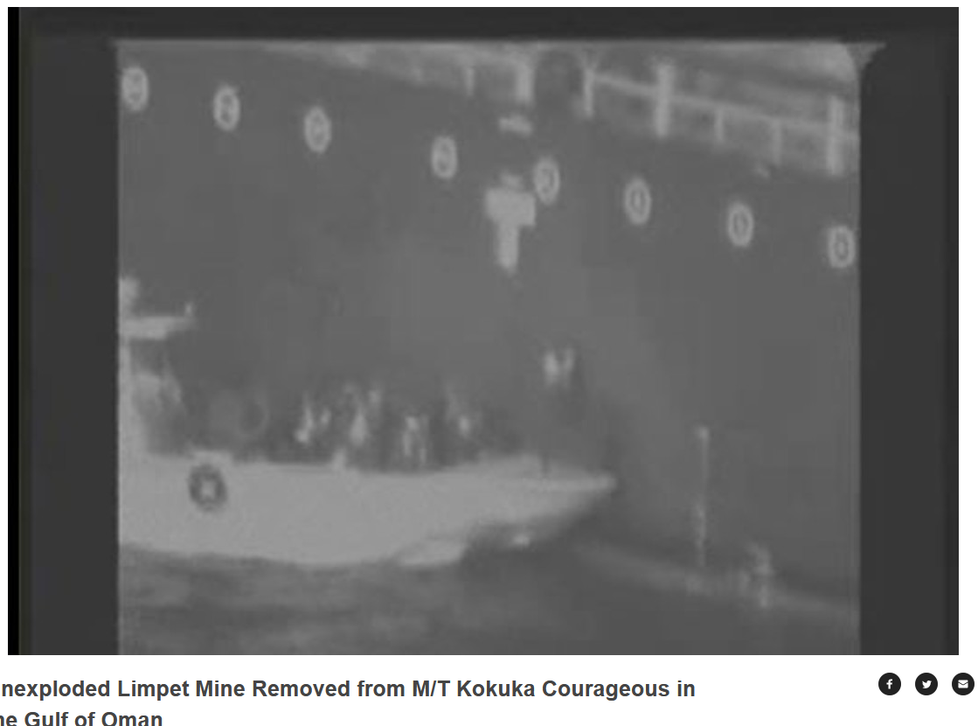
Okay, but where have all those other images come from that we keep seeing in the news?
Well, first we have the BBC:
https://www.bbc.co.uk/news/world-us-canada-48671319
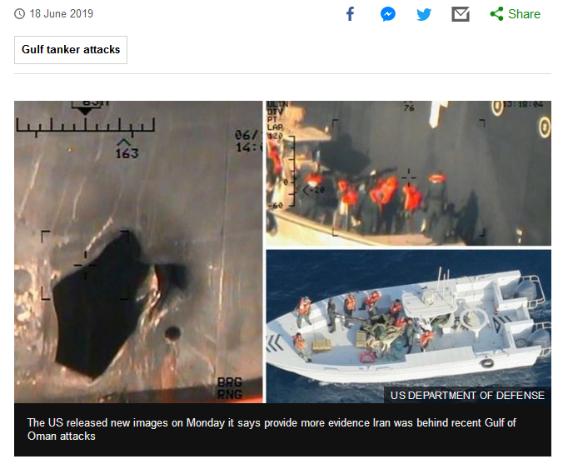
Lovely colour they have there, but not in the original. Also, there are the gridlines again.
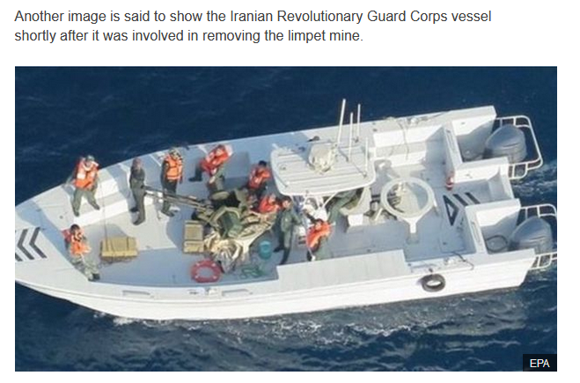
Euronews:
https://www.euronews.com/2019/06/17/us-military-releases-new-images-from-oil-tanker-attacks
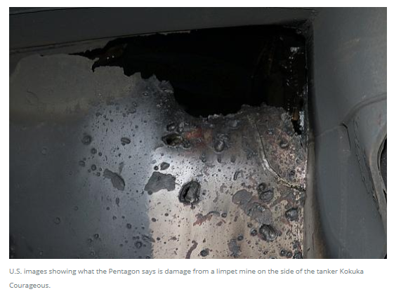
Reuters:
https://uk.reuters.com/article/uk-iran-nuclear/u-s-navy-says-mine-fragments-suggest-iran-behind-gulf-tanker-attack-idUKKCN1TK1Z1
(From the vid, stills)
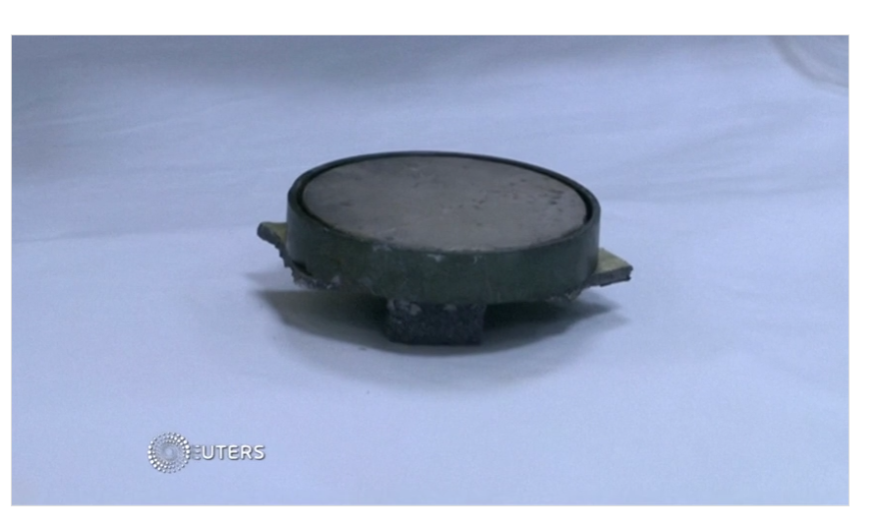
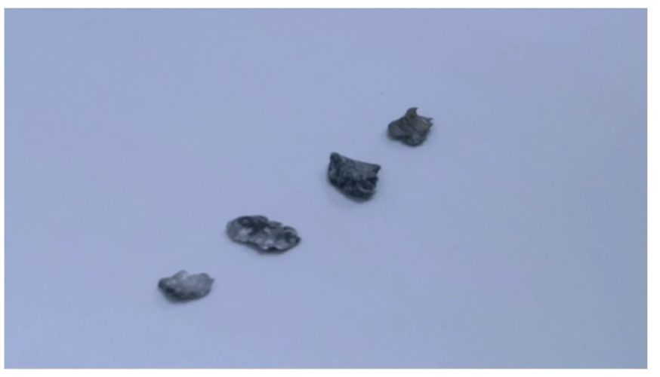
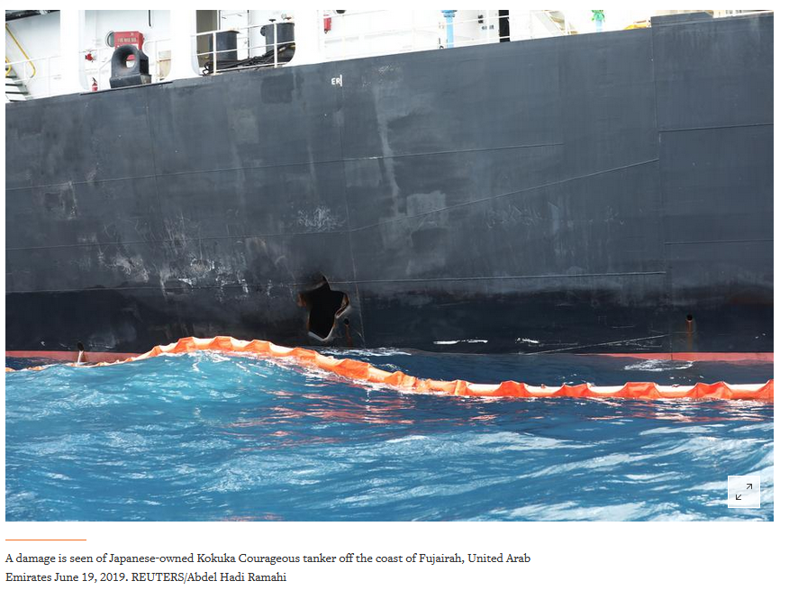
So, with this in mind, let’s see if this is what they say it is etc. It may be or it may not.
But just reminders to any special forces out there, don’t forget this handy checklist:
Attack in daylight? Check
Use our own boats? Check
Use a white boat instead of one that may have camo? Check
Assemble as many on the boat, so it may capsize? Check
Don’t forget to wear high-vis lifejackets, as we’re Special Forces? Check
--
Let’s start with the main item, the boat that was used. Here is the official wording from the original site:
“At 4:10 p.m. local time an IRGC Gashti Class patrol boat approached the M/T Kokuka Courageous and was observed and recorded removing the unexploded limpet mine from the M/T Kokuka Courageous (video attached).”
And this was the image (remember the colour one appeared later):
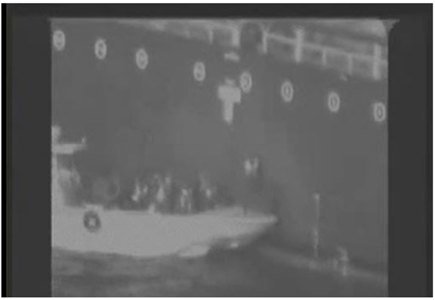
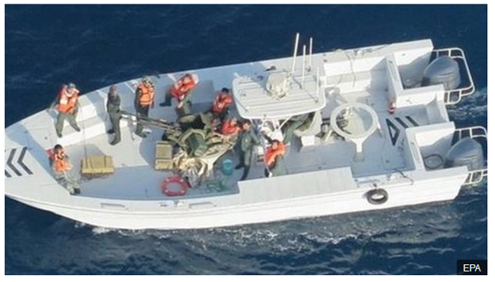
Looks like the colour image was supplied by the US Department of Defence, but can’t find anything on their website. Anyhow, on we go. Back to the quote:
“At 4:10 p.m. local time an IRGC Gashti Class patrol boat approached the M/T Kokuka Courageous and was observed and recorded removing the unexploded limpet mine from the M/T Kokuka Courageous (video attached).”
So, it’s an IRGC Gashti Class patrol boat. The noticeable things on the pictures are the black lines at both ends of the boat. Also, the (let’s call it a roof) over the drivers head. The on-board motors. And we’ll ignore the fact they’re all looking at the camera
For this, I’m trying to locate actual images of an Iranian IRGC Gashti Class patrol boat. Not easy, but let’s see what we can find.
First, we have a tour back in 2014, with photos:
https://www.uskowioniran.com/2014/02/president-rouhani-tours-iran-navy-and.html
And near the bottom, a photo or two of the IRGC. Doesn’t state Gashti. But apparently, it’s an Urdu word for Patrol, among other things:
https://dict.hinkhoj.com/gashti-meaning-in-english.words
So, let’s assume it’s just an IRGC Class patrol boat.
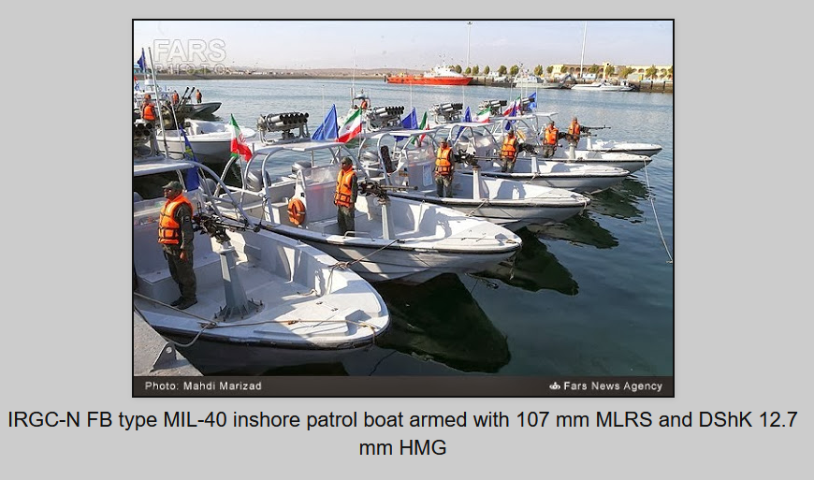
Not exactly certain, but although this was taken in 2014 (as per the article), I can’t see any black lines on the front. Also, it seems smaller, so maybe this is an earlier model.
Also, IRGC is actually the Islamic Revolutionary Guard Corps. So, from the US description, it’s a:
IRGC Gashti Class patrol boat….or translated to:
The Islamic Revolutionary Guard Corps Patrol Class patrol boat….
Or just IRGC Class patrol boat? Seems a bit flimsy, when you see in the news article that they’re a bit more varied:
IRGC-B C-14 China Cat, IRGC-N FB type MIL-40, IRGC-N Toragh.
Maybe it’s an IRGC-N type boat? Will see if that comes up with anything.
I must admit, I’ve searched for ages, trying to match the boat. I even looked here and searched for each type of vessel, and nothing comes close:
https://en.wikipedia.org/wiki/List_of_current_ships_of_the_Islamic_Republic_of_Iran_Navy
So, until they can give us the actual name, I’m holding that one in judgement.

Onto the tanker. First off, the actual details about the tanker itself, and what it looks like. This is not in the footage, but as it is when it left the dock etc. The official transcript from the US site states that it was the M/T Kokuka Courageous that the occupants of the boat were seen removing the charge from.
The M/T stands for Motor Tanker, so let’s ignore that. This is the only one with that name:
https://www.marinetraffic.com/en/ais/details/ships/shipid:5502927/mmsi:371880000/vessel:KOKUKA%20COURAGEOUS
So, now that we can see what type it is, let’s see what we can see
The tanker is from Panama, and it’s a tanker – hazard B...
https://www.vesselfinder.com/vessels/KOKUKA-COURAGEOUS-IMO-9568495-MMSI-371880000
The IMO number is 9568495, and that is the identifier of which each vessel has its own unique number.
Now, this is where it gets interesting. The actual image of the fire is here:
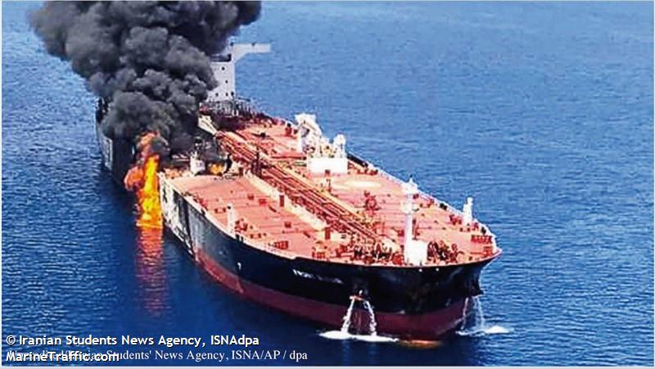
And also here:
https://www.vesselfinder.com/news/15656-US-releases-video-it-claims-shows-Iran-removing-mine-from-tanker
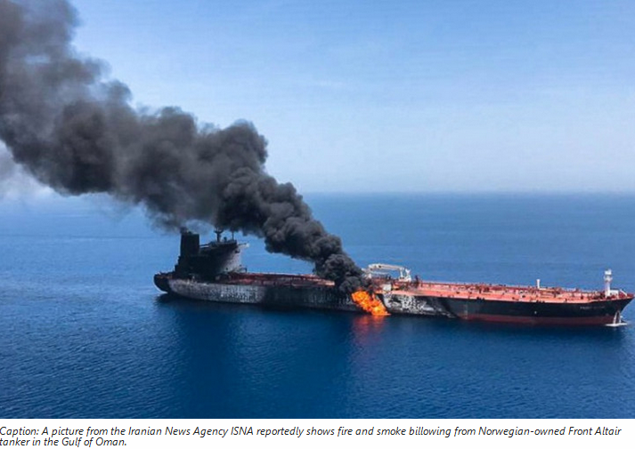
But both of these images are stating it’s the Front Altair tanker, the other tanker that was observed to get hit at the same time. You can tell it’s the same image from the fire damage:
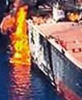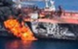
The partial bit of a ‘triangle’, and let’s call it ‘a step’
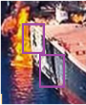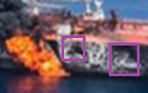
So, what does the Kokuka Courageous look like? Well, from those above links, and trying to get similar angles:
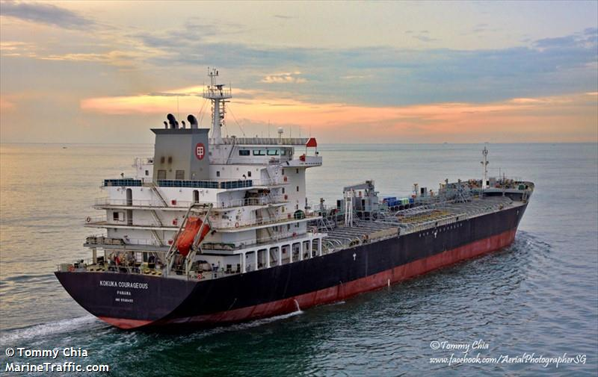
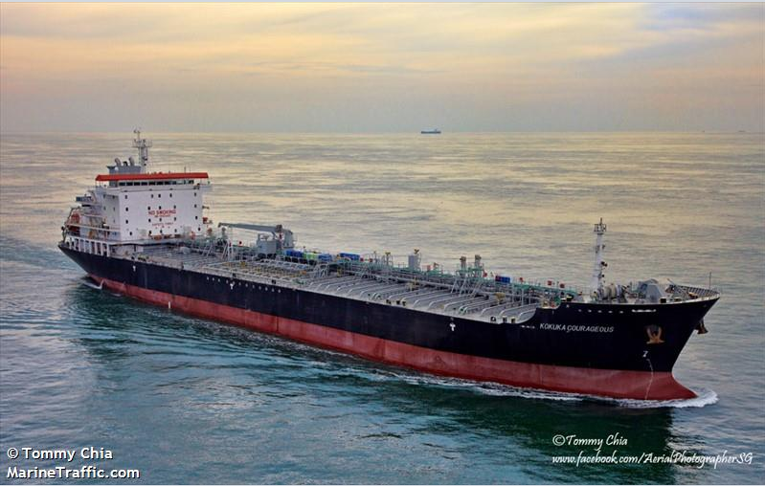
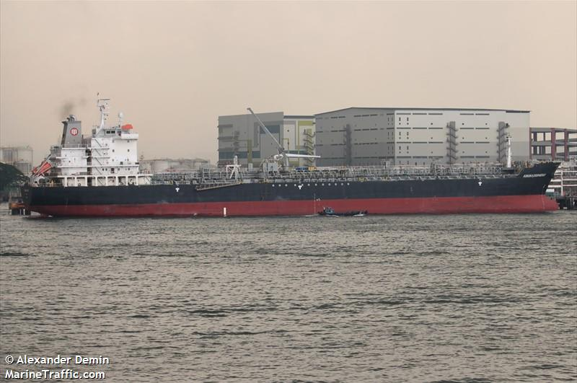
So, you can tell it’s different at the bow (front) of the tanker. First by the length of the name, and also the ‘steps’ of the edging near the front.
Altair vs Kokuka:
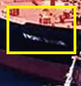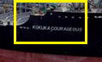
Just seems strange that the video we have of the boat and people removing the limpet is from the Kokuka, yet the fire is only shown on the Altair.

Now, remember we have this nice image:

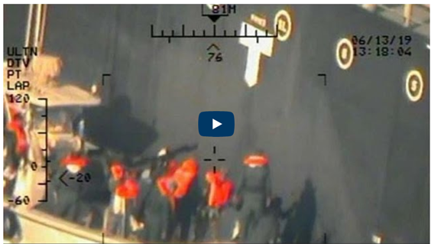
This looks like it’s from the Kokuka , as the ‘T’ that is just to the left of the ‘O’, and this can be seen in the above pictures. But there is one thing that I want to look at. The boat that they used must be pretty large, as you can see from above (note the railings at the top and the T, in relation to the boat).
So, what does a tanker that is empty vs full actually look like?
http://www.ellenrwald.com/uncategorized/example-full-tanker-empty-tanker/
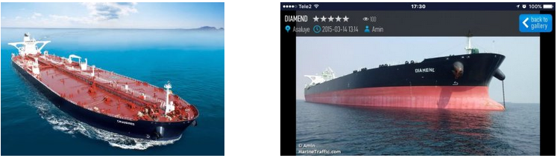
So, you can see that the red hull is under water in the first, as that is full.
I know what you’re going to say, it doesn’t state that the Kokuka was hit in the US website, just that they removed a limpet. But that’s not what it says in the news:
https://www.euronews.com/2019/06/17/us-military-releases-new-images-from-oil-tanker-attacks
“The Pentagon released images, many taken from a U.S. Navy helicopter, showing what it said were Iranian forces removing an unexploded mine from the side of the Japanese-owned Kokuka Courageous oil tanker in the Gulf of Oman.

Other photos show a large hole on the side of the Courageous, above the water line, that officials say appears to have been caused by another similar mine”
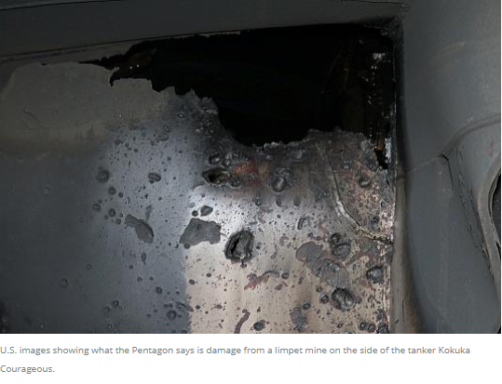
So, it was hit, so let’s see if we can design some sort of scaled drawing etc.
Now, this had to be done using my skill in MS Paint
So, first off, we have the actual tanker when it’s empty:
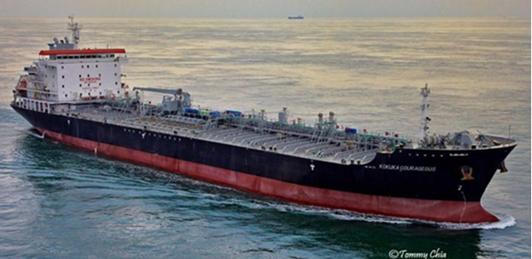

And now with the red hull removed, that is full:
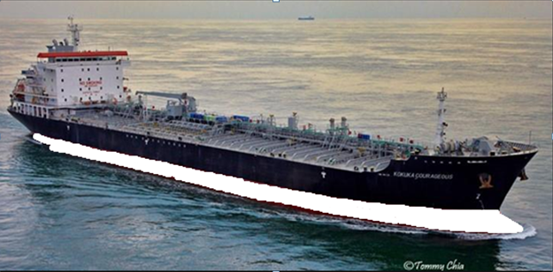
Now, we need to somehow get the scale of the people. So, looking here I’ve used this as a basis for the person. Also, take note of the bottom right; you can see part of the red hull, so it’s pretty much as above:
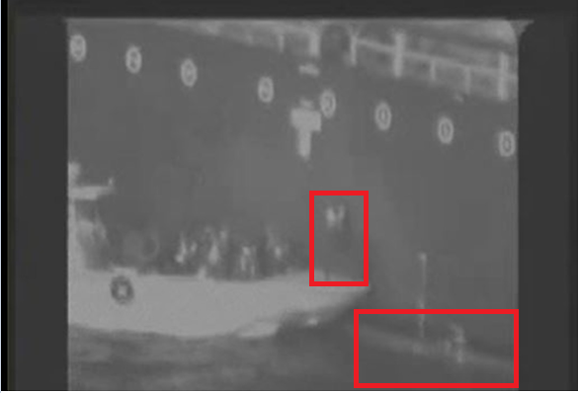

So, we have to kind of zoom in and get the image of the tanker with the hull removed, near the ‘T’ to be the same size as the still from the video.

So, the main person we’re using is this one:
And we also need that ‘T’ for comparison of the size:

And put together:
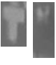
So, looking at the still, we can see that from just about the top of the red part of the hull to the railings, its 3 people high:
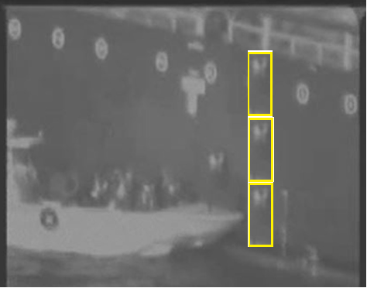
Now, when you try and zoom in on an image that is small in the first place, it gets very pixilated. So, for this reason, I’m going to try looking backwards. So, the image that I have (with the hull removed and the T showing) is here:
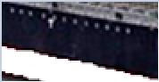
So, now we need to see about that T and try and size it up with the still that we have.
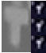
So, we can see it’s about 3 times smaller (the image I have versus the video still). So, let’s see if I can resize the person, and match it up.
So, it’s normally at 100% in Paint, and 3 times smaller is 100/3 = 33%
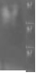
So, now that we have the sizes, lets add it to my new image:
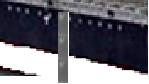
Hmmm, that doesn’t add up?? How about the one (same picture remember) but with the red hull visible?
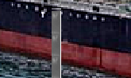
How does that work? So, it’s either one person or two (without/with the hull). So, how come the third is there? It was there on the main video.
The only thing I can think of is that it’s not the same tanker. But then my sizes may be wrong, but we used the T to scale it.
Okay, so looking at this scaling, what happens if we scale the small T that we have, and try and ‘stretch’ it to match the same size? Will that still be 3 times as small?
So, I manged to resize the original little T. It’s a bit blurry as it’s small in the first place, as I already explained about the pixels when you resize images.
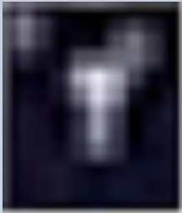
So, if we then add our original T from the still, what does it look like?
Well, first we need to ‘crop’ the original, so it’s just the main T:
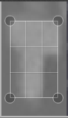
So, this then becomes:

Now, let’s see if we can do the same with the zoomed in T
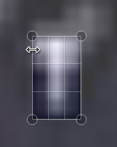
To become:

And side by side:

But I think the T on the left has more blur at the bottom, so from what I can see, its 3x the size.
So, yes the size is correct, but the ‘people’ just can’t be right.
So, with this on mind, I’m leaning towards the side that it’s not the same tanker. Again, this is just my opinion from the research I have conducted.

Also, I hear people saying, what about those lines above the T, you can’t see them in the originals? Well, no you can’t but then most are taken from far away. But after much searching, I found one that is very clear:
http://uragasuido.opal.ne.jp/blog/2017/05/EM5W8899.html
Can’t read Japanese, but it’s the pictures I’m after
http://uragasuido.opal.ne.jp/img/7/EM5W8899.jpg
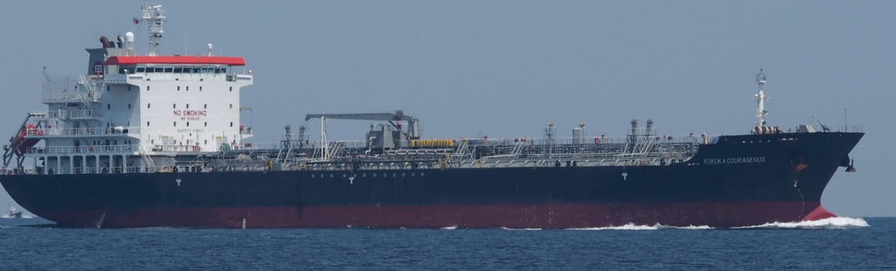
And nicely zoomed in on that T:
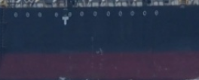
Which matches the image we have:


So, what is my conclusion for this bit of research? Remember, this is just my opinion; everyone is free to make their own minds up.
The small white boat that was used I’m of mixed opinions. Firstly, it doesn’t seem to match any of the small boats that Iran has. Add to the mix, that the actual name of the boat wasn’t given, just a vague patrol boat.
The tanker footage from the video is showing that it’s the original tanker, but with one small caveat: the size. I’m unsure about this, matched up the T with both tankers, and they match, but yet the size of the person just doesn’t. If the tanker on the video is 3x closer (the T helps on this), then in theory everything is 3x larger. Making the people 3x smaller and superimposing onto the original tanker should fit…but it doesn’t.
Now, there may be a very good reason for this, and I’m definitely open to any suggestions as to what this may be caused by etc.
This was also a very lengthy research case, but I tried to look at as many areas as possible.

