Now, this is a side bit of research. Earlier I’ve looked at the tankers that were attacked, but I felt that the research wasn’t complete. The final bit I wanted to look at was the actual limpet mine.

So, the main bit of research is here:

<http://eddiesresearch.com/2019/07/15/oil-tanker-attack-june-2019/>

And in there are some pictures, so adding the same ones here as well:

<https://uk.reuters.com/article/uk-iran-nuclear/u-s-navy-says-mine-fragments-suggest-iran-behind-gulf-tanker-attack-idUKKCN1TK1Z1>

(From the vid, stills)

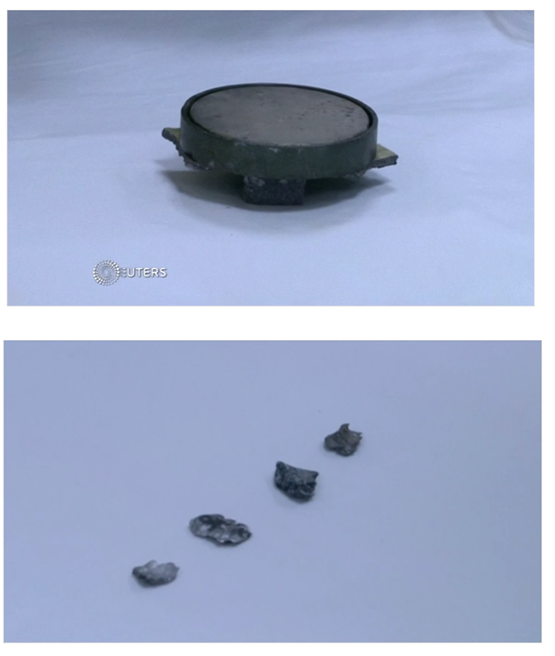

So, a brief history of what a limpet mine is etc. Basically it’s a mine that is used by the navy, which can be attached to the target by use of magnets. It’s called a limpet after a type of sea snail that clings tightly to rocks and other hard surfaces.

Hence why the limpet mine was ‘allegedly used’ in the tanker attack.

So, let’s look at the above pictures. Well, the second tells you absolutely nothing. I can find scraps of metal like that on the side of the road. So, we’re on the first one.

Now, as usual, more images have surfaced since the attack first took place. Here is another image:

<https://pressfrom.info/uk/news/world/us-news/-343597-mines-used-in-tanker-attacks-strikingly-like-iran-s-us-says.html>

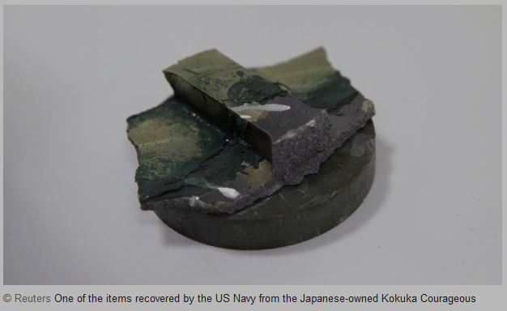

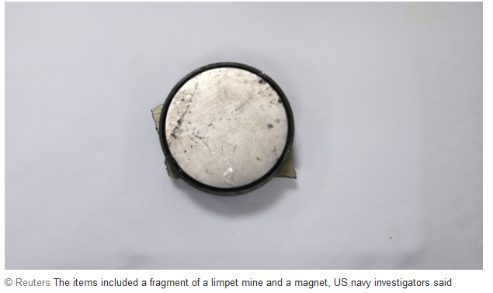

I’m assuming (from the 3 pictures) that the one that has a big chunk of metal on top, is the other side of the mine, that the other two show.

More follows:

<https://www.ntd.com/us-navy-expert-tanker-attack-mine-resembles-iranian-mines_345930.html>

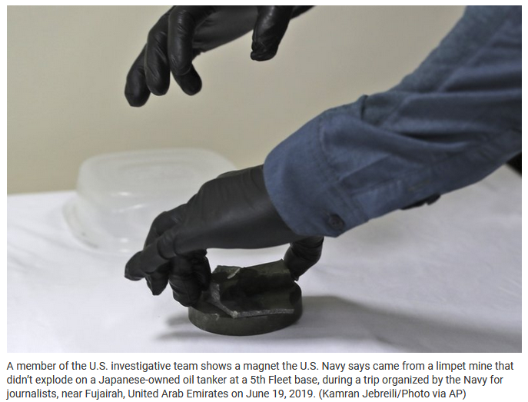

<https://www.thetalkingdemocrat.com/2019/06/iran-tanker-attack-mine-found-by-us-navy/>

This shows rough size:

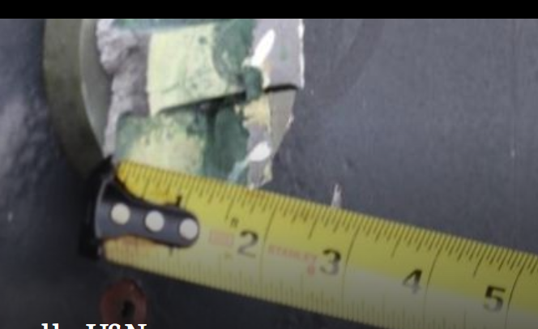

Okay, so let’s begin. First off, can we find out what an Iranian Limpet mine looks like? Well, maybe, but will see if there are others.

Here is a site, and no, it’s not in English:

[https://www.farsnews.com/news/13940711000255/%D8%B1%D8%B5%D8%AF-%D8%A2%D9%86%D9%84%D8%A7%DB%8C%D9%86-%D8%AE%D9%84%DB%8C%D8%AC-%D9%81%D8%A7%D8%B1%D8%B3-%D8%A7%D8%B2-%D8%A7%D8%AA%D9%88%D8%A8%D8%A7%D9%86-%D8%B4%D9%87%DB%8C%D8%AF-%D8%AE%D8%B1%D8%A7%D8%B2%DB%8C-%D8%AA%D9%87%D8%B1%D8%A7%D9%86-%D9%86%D9%85%D8%A7%DB%8C%D8%B4-%D9%85%D9%88%D8%B4%DA%A9-%D8%AC%D9%86%D8%AC%D8%A7%D9%84%DB%8C](https://www.farsnews.com/news/13940711000255/رصد-آنلاین-خلیج-فارس-از-اتوبان-شهید-خرازی-تهران-نمایش-موشک-جنجالی)

And the link works, but here is a screenshot:



So, in there if you scroll just past halfware, you’ll see this image:

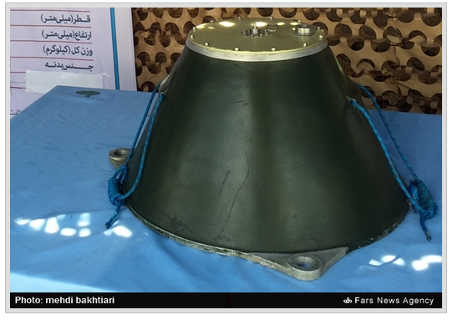

And this wording:

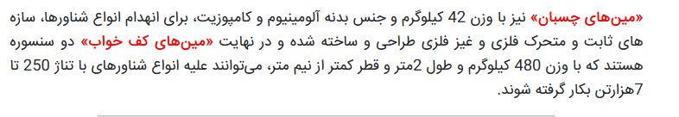

So, using an online translator:

<http://www.translation2.paralink.com/Persian-English-Translation/>

It states by Microsoft Translation:

«Fitting» mine is also weighing 42 kilograms and body material aluminum and composite materials, for the decommissioning of vessels types, static and dynamic structures of metal and metal غیز designed and built and finally the "Maine two floors that are snsurh with" sleep-weight 480 kg and a length of less than half a meter in diameter and 2متر, Against a variety of vessels with tonnage can be up to 250 7هزارتن are applied.

And by Google Translator:

The '42 kg' mines and aluminum and composite body are designed and manufactured to eliminate all kinds of floats, fixed and removable steel and non-metallic structures, and finally the 'floor mines' are two sensors weighing 480 kg. And 2 meters in length and less than half a meter in diameter can be used against all types of vessels with a tonnage of 250 to 7,000 tons.

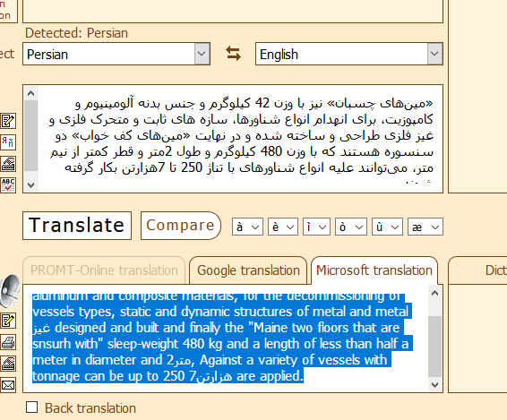

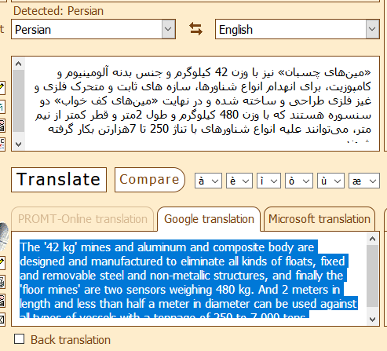

But that doesn’t make sense. It says its 2 metres in length and half a metre in diameter. So, looks like it can’t be this one, let’s see if I can find any others.

Unfortunately, I can't find much on limpet mines as such. I spent a good portion of my time pouring over brochures from the many military exhibitions, trying to spot a mine. Seems they sell everything, from jets to vessels, bullets to backpacks, but not mines?? Seems strange, as most countries that have a navy need to ensure that they're secure against the threats out there.

The nearest I could find was another manufacturer, but then this is just one of countless companies out there. Not just the main ones you hear of in passing, but companies based all over the place, specialising in various types of equipment.

The one I looked at was this:

<https://electronica-submarina.es/wp-content/uploads/2018/08/SAES_MILA_LimpetNavalMine_english-1.pdf>

But like I say, its only one company, and they could sell this one to anyone, as they're hardly likey to post their customers details, like any other company would.

So, my conclusion to this small bit of research? Well, from the pictures that the US posted that showed fragments and the actual main part that didn't explode (apart from the intact one of course), it is of my opinion that we cannot say it is an Iranian mine, or any other country, as there are no distinguishing numbers, markings etc. Also, the size is a lot smaller than the one and only photo that I could find, and strangely enough, it also seems to be of the same type as Wikipedia. Why not link a nice US, UK or even say Italian mine? Anyway, that's another story.

<https://en.wikipedia.org/wiki/Limpet_mine>

Hopefully you liked this latest piece, it was small, but looking at one piece of equipment proved to be very hard indeed. Maybe in the future when they 'find' better images, I'll have another look :)