For this research, I'm looking at the claim that music is just as effective as drugs in calming nerves before surgery.

The main news article is here:

https://news.sky.com/story/music-just-as-effective-as-drugs-for-calming-nerves-before-surgery-11766117

And is also mentioned on other news outlets, but I'm just focusing on this one.

Now, the article itself states the following:

“"Music has charms to sooth a savage breast," the poet William Congreve said back in 1697.

We have long known about music's soothing qualities, but researchers now claim it could be just as effective as drugs for calming patients.

A clinical trial in the US compared the levels of anxiety felt by patients who were prescribed the drug midazolam and others who were told to listen to music.

Those involved in the study were having a type of regional anaesthetic, or peripheral nerve block.

Researchers split 157 adults into two groups, with the first being given 1mg to 2mg of midazolam, which was injected three minutes before the peripheral nerve block.

The other group were given noise-cancelling headphones and listened to English band Marconi Union's Weightless - which has been described as the "world's most relaxing song".

According to Forbes, the band collaborated with a therapist to produce the ultra-relaxing tune, which aims to lower the listener's blood pressure, stress levels and heart rate.

Pre-operative anxiety is common and can raise levels of stress hormones in the body, affecting its ability to recover after surgery, according to a team from the University of Pennsylvania writing in the journal Regional Anaesthesia and Pain Medicine.

The study scored patients' levels of anxiety following the two treatments - and found participants who had listened to music were just as relaxed as those who were given the sedative

However, patients in the drug group were happier with their overall experience, although this may have been because participants were not allowed to choose the music they listened to.

Both doctors and patients also thought it was easier to communicate without the music.

Following the study, the team said "music medicine" could be used as an alternative to midazolam before peripheral nerve block injections.

But they said "further studies are warranted to evaluate whether or not the type of music, as well as how it is delivered, offers advantages over midazolam that outweigh the increase in communication barriers"."

So, for this bit of research, I'm going to look at the study itself, see what the conclusions are. Also, what is the drug midazolam, and what is peripheral nerve block injections.

So, onto the actual study. Although it doesn't link to it in the article, its actually here:

https://rapm.bmj.com/content/early/2019/06/25/rapm-2018-100251

How do we know this is the study? Well, in the news article, it states that there are 157 adults split into two groups, one with midazolam and the other with music. And in the study you will see this diagram:

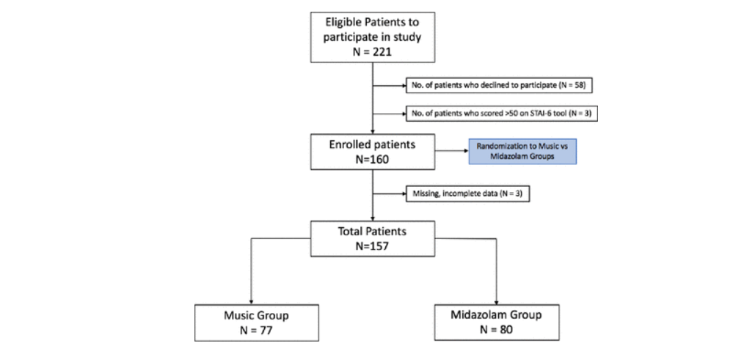

Which you can see there are 157 patients split into two groups, near the bottom of the diagram.

So, first of all, what is midazolam? Well, according to Drugs.com, its used to sedate a person who is having minor surgery, dental work, or other medical procedure.

https://www.drugs.com/mtm/midazolam.html

More information from other websites are listed here:

https://www.medicines.org.uk/emc/product/6063/smpc

https://bnf.nice.org.uk/drug/midazolam.html

As usual with any types of medication or drugs etc., there are side effects, and cases when the drug may not be advised to be taken.

https://www.medicines.org.uk/emc/product/6063/smpc#CLINICAL_PRECAUTIONS

Brief list includes anyone over 60, chronically ill, chronic respiratory insufficiency, renal failure, impaired cardiac function etc.

And of course there can be side effects:
https://www.medicines.org.uk/emc/product/6063/smpc#UNDESIRABLE_EFFECTS

Immune system, nervous system, cardiac, vascular, respiratory, skin, injury disorders, to just list a few. Check out the above link, and its startling how many there may be. But remember, the majority of these hardly ever occur.

So, how does midazolam actually work? On a side note, the drug is used in executions, well before it happens, to calm the nerves. In simple terms, it slows down brain activity, which then allows relaxation and eventually sleep to occur. But in medical procedures, as this main article is about, it causes drowsiness, relives anxiety and prevents the person from remembering the procedure.

And in scientific terms, it binds a brain chemical known as GABA (gamma-aminobutyric acid (GABA)-benzodiazepine receptor complex) to brain receptors, which hinders the flow of electrical impulses to the brain.

https://www.livescience.com/51384-execution-drug-midazolam-effect.html

Okay, so we now know how it works, and what it does. So, what's this peripheral nerve block injections? Well, its exactly as you can read: Its an injection that centres around the peripheral nerve, and its to help diagnose and also produce pain relief.

So, used in conjunction with the midazolam, first it calms the nerves, and makes you relaxed, and then the injection produces the pain relief, so that surgery can be painless and the patient will not remember the procedure afterwards.

Now, onto the next part of this article: the music. It states that the most relaxing song in the world was used, Marconi Union's Weightless. Here it is:

https://www.youtube.com/watch?v=UfcAVejslrU

Now, I think its all down to personal taste, as some may say that certain classical songs are more relaxing, or other types of electronic music, say Enigma for example. Anyway, that's not the purpose of this research, but to look at the actual article in question :)

So, now we have the song, and maybe you've listened to it, and we know the drug and how it works, and side effects etc., let’s look at the actual body of the article.

I've also uploaded a full pdf of the research as sometimes over time, they either remove or just provide summaries, which doesn't give the whole picture.

It states in the news article:

"The study scored patients' levels of anxiety following the two treatments - and found participants who had listened to music were just as relaxed as those who were given the sedative.

However, patients in the drug group were happier with their overall experience, although this may have been because participants were not allowed to choose the music they listened to."

Now, this is what the research gave for its Results and Conclusions:

Results: The change in the State Trait Anxiety Inventory-6 (STAI-6) anxiety scores from after to before the procedure were similar in both groups (music group −1.6 (SD 10.7); midazolam group −4.2 (SD 11); p=0.14; mean difference between groups −2.5 (95% CI −5.9 to 0.9), p=0.1). Patient satisfaction scores with their procedure experience were higher in the midazolam group (p=0.01); however, there were no differences in physician satisfaction scores of their procedure experience between groups (p=0.07). Both patient and physician perceptions on difficulties in communication were higher in the music group than in the midazolam group (p=0.005 and p=0.0007, respectively).

Conclusions: Music medicine may be offered as an alternative to midazolam administration prior to peripheral regional anaesthesia. However, further studies are warranted to evaluate whether or not the type of music, as well as how it is delivered, offers advantages over midazolam that outweigh the increase in communication barriers.

Now, lets break down how these scores were achieved and what they mean. Firstly, its using the STAI-6. This is Speilberger's validated tool.

Firstly, the STAI is the State-Trait Anxiety Inventory, and its used to diagnose anxiety:

https://www.apa.org/pi/about/publications/caregivers/practice-settings/assessment/tools/trait-state

But for this research, the same tool was developed to use a six-item short-form of the tool:

https://onlinelibrary.wiley.com/doi/abs/10.1111/j.2044-8260.1992.tb00997.x

I'm not going to delve too deep into this, as its making my own head swirl, just trying to fathom out what the tool was initially, so you're very welcome to read up on this if you wish.

Basically, according to the research paper, the traditional tool has a state and trait portion, each with 20 questions, with score ranges of 20-80. But the STAI-6 has a score range of 6-24, but to match the original, they divided the scores by 6 and multiplied by 20 to give a comparable score of 20-80.

So, we now look at the actual table of results. Its viewable online, you just need to select it to open in the page.

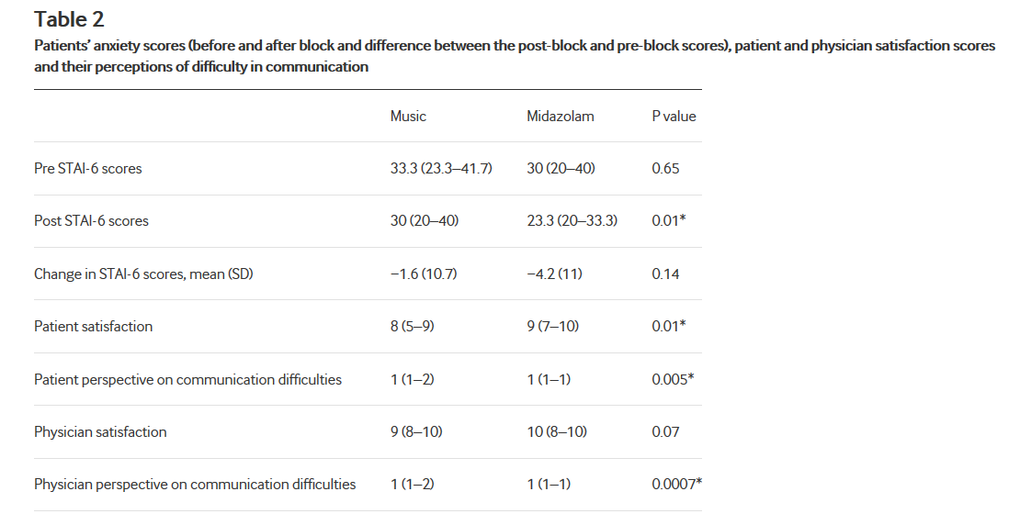
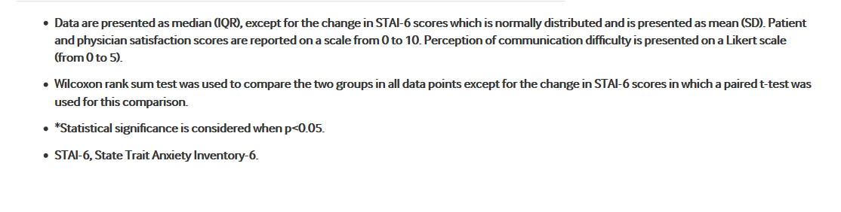
Okay, looking at the table it does look a little confusing to say the least, but it can be broken down, so that its easier to understand.

There are 3 columns: music, midazolam and P value. The p-value is a statistical value, and its the probability that, when the null hypothesis is true, the statistical summary would be equal to, or more extreme than, the actual observed results. Now, I hardly use Wikipedia as a reference, but just from looking here, you can see if definitely used in more applied maths, of which I'm not even going to attempt:

https://en.wikipedia.org/wiki/P-value

So, as they have actually given a breakdown of the actual results themselves, its far easier, and less time-consuming, if I show wording here (already stated above):

“Results: The change in the State Trait Anxiety Inventory-6 (STAI-6) anxiety scores from after to before the procedure were similar in both groups (music group −1.6 (SD 10.7); midazolam group −4.2 (SD 11); p=0.14; mean difference between groups −2.5 (95% CI −5.9 to 0.9), p=0.1). Patient satisfaction scores with their procedure experience were higher in the midazolam group (p=0.01); however, there were no differences in physician satisfaction scores of their procedure experience between groups (p=0.07). Both patient and physician perceptions on difficulties in communication were higher in the music group than in the midazolam group (p=0.005 and p=0.0007, respectively).”

So, it seems that they were very similar between the two groups with regards the SD (Standard Deviation), but seemed that the midazolam scored lower than the music group overall. Also, they found it harder to communicate with the patients with music on (hardly surprising myself, I'm the same if I'm listening to music and someone starts to talk).They discussed this, and thought that it could be due to many factors: choice of music, noise vs non-noise cancelling earphones etc.

So, is the article correct in the way its written? Yes it is:

Title – Music is just as effective as drugs for calming nerves – Yes (more or less)
However, patients in the drug group were happier with their overall experience, although this may have been because participants were not allowed to choose the music they listened to – Yes, this was discussed in the later part of the research.

Both doctors and patients also thought it was easier to communicate without the music. - Kinda Yes, they thought it was due to music, type of earphone (but they neglected to state that the patient may be fully engrossed in the music, and an external voice was a distraction).

Following the study, the team said "music medicine" could be used as an alternative to midazolam before peripheral nerve block injections. - Yes, that was the conclusions.

So, there we have it. The article is correct, but I'm still not convinced. As much as I hate using drugs and having many types of pills and potions administrated, just listening to music prior to some surgery instead of something that will actual calm me down and block those nerves. But they didn't (from what I can gather) ask the patients how they felt after the surgery. I think that is something that also needs to be factored in.

Well, hope you enjoyed this bit of research, a little different to my usual stuff, but I like to look at many things :)

