So, I'm pretty certain everyone in the world has heard of the latest virus that's sweeping the world. Now, I wasn't going to do any articles on this, as I have my own views on this, some of which are a miss-mash of what I feel it’s really about.

If you follow, or feel that it’s not what it’s said to be, but a hidden attempt at something else, then you probably have your own theories on it. For me, it is of my opinion that it’s going to lead to everyone being kept inside, growth to reduce and recession to kick in. There was an article in the The Economist many years ago (1998), about one currency by 2018 (may have been delayed due to Brexit), but why do people think it’s a physical currency, or a currency that is specific, e.g. dollar, euro etc.? Could it not be online currency (not bitcoin type), but all money online for ever, no physical money. That way, it can all be controlled, as it’s all online.



Anyway, that's not what this article is about but the 'cold' that is sweeping the world, where we're all dooooomed, dooomed, arrrgghhhhh......

So, let’s look at what I think people need to look at, and that's good old stats, numbers, real facts, and then you can make your own mind up, instead of just accepting what someone tells you.

So, how to begin? Well, let's look at other kinds of things that kill people worldwide, each year. I will cover all sorts of things here, so bear with me, but then you can see that the thing that is causing mass panic isn't as bad as you really think.

Now, the World Health Organisation (WHO) actually has a database:

https://www.who.int/healthinfo/mortality_data/en/

<https://apps.who.int/healthinfo/statistics/mortality/whodpms/>

Basically, you click on the Select Parameters, and in there select what you want, per country, per year. It’s only up to, but you can get the gist of what it shows.

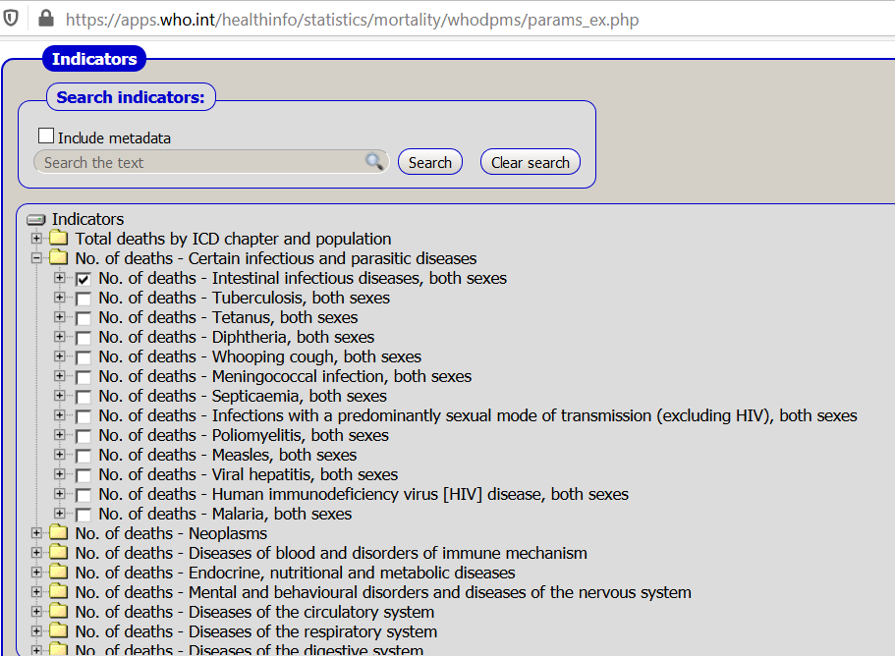

So, as there is a lot of info here, and will make more sense as you look for your own country, I'm just going to focus on the UK and US, for each death, and for 2015, as there doesn't seem to be much from 2016.

Taken a while, but got an Excel list of the numbers. I have also stated which are infectious diseases, so that they can be taken into context with the latest scare. Plus, in some cases, I've also put the basic terminology as some things people are not familiar with.

I've created a snapshot here, of just the Infectious ones, but there are more details in my article and video:

UK US

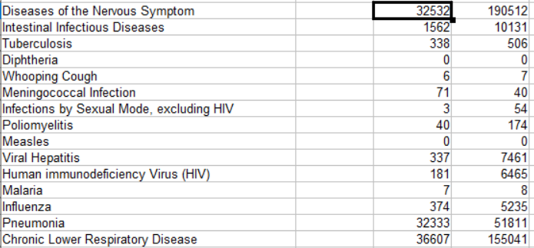

So, just from 2015, you can see that Pneumonia and Chronic Lower Respiratory Disease have the largest values, well into the 30,000's for the UK, and a heck of a lot more in the US, due to landmass etc.

So, can we find out anything a bit more recent? Well, it’s not an easy task, but yes you can. And remember, that a good portion of the people dying from the Coronavirus have the famous underlying health conditions, immune systems are shot, and any medication that may be given to them, which will be on top of their current stock, may have adverse reactions. But they don't get listed as medication issues, but the virus, Very, very curious if anyone has had it, was 100% healthy, had no medication given to them, and died. I bet it'll be a long time before we even hear of one of those.

Now, the WHO does have data, but it’s not in the current database, but uploaded in a strange format, they say:

<https://www.who.int/healthinfo/statistics/mortality_rawdata/en/>

Some of the data files, when reading the 'documentation' are over 2 million records!!! So, yes, Excel will probably crash ☺

I'm looking at file **MortIcd10.zip** to begin with, and I needed to open up the country codes as well. This isn't in the usual format, like UK, US, JP etc. but as numbers. As this was a small file, I opened this in Word and the details I needed are:





And in the documentation, it explains the list of causes, e.g.:

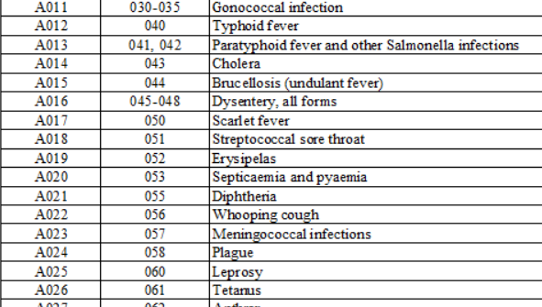

Now, due to the fact I don't own any statistical software (which is what is needed to read the data easier, I'm opening in Word:

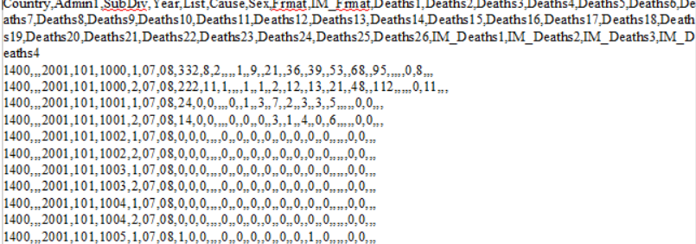

So easy, a child could understand it ha-ha.

Anyway, I'm going to attempt to reduce the numbers down, but just keeping the Country (first numbers) as UK and US, e.g. 4308 and 2450.

Now, as a side-line, I also carried on with this bit of research on my other computer. So I went to the exact same link, and it comes back and states they’ve been moved or deleted!!!

Has the link changed? Nope, as even here it has a link to it:

<https://www.who.int/healthinfo/mortality_data/en/>

And I still can’t get in. Have they removed them? Well, they sometimes get a 404 page, as now they’re back, but luckily I have them on my laptop, so that’s good ☺

Believe it or not, I wouldn’t advise opening this unless you really want to. Why? Well, it’s well over 1000 pages. In fact, I looked and started deleting the stuff I didn’t need to reduce it, at around 9000 pages, and when I deleted some, it was stopped at around 14,000!!

So, I have basically stopped on that one, as it’s massive. Tried to find each number, but there are 100’s of random numbers in there, and it was freezing each time ☹

--

Onto the next database, one by the Office for National Statistics (ONS) in the UK.

<https://www.ons.gov.uk/peoplepopulationandcommunity/birthsdeathsandmarriages/deaths/articles/quarterlymortalityreports/octobertodecember2019>

Now this one may be a bit more relevant, but as you can see from the above link, it’s a quarterly list.

All the previous releases are here:

<https://www.ons.gov.uk/peoplepopulationandcommunity/birthsdeathsandmarriages/deaths/articles/quarterlymortalityreports/previousReleases>

To make this relevant to the current virus deaths, let’s just look at 2019.

<https://www.ons.gov.uk/peoplepopulationandcommunity/birthsdeathsandmarriages/deaths/articles/quarterlymortalityreports/januarytomarch2019>

<https://www.ons.gov.uk/peoplepopulationandcommunity/birthsdeathsandmarriages/deaths/articles/quarterlymortalityreports/apriltojune2019>

<https://www.ons.gov.uk/peoplepopulationandcommunity/birthsdeathsandmarriages/deaths/articles/quarterlymortalityreports/julytoseptember2019>

<https://www.ons.gov.uk/peoplepopulationandcommunity/birthsdeathsandmarriages/deaths/articles/quarterlymortalityreports/octobertodecember2019>

However, there is one drawback with the data, it doesn’t show how they died, as in infections, influenza, etc. But what I can show is the ‘numbers’ per quarter, and at least there is something to see. They’re listed under ‘Main Points’:

There were 134,337 deaths in England in Jan-Mar 2019.

There were 118,848 deaths in England in Apr-June 2019.

There were 113,348 deaths in England in Jul-Sept 2019.

There were 129,821 deaths in England in Oct-Dec 2019.

So, as you can see there are (unfortunately) a lot of people dying per year, so why isn’t that on the news? Well, let’s take Oct-Dec for example.

It states that most deaths are aged 75 or over, as this is due to many factors obviously connected with age. But again, it isn’t stated much.

But like I say, can’t really use this in comparison with what I’m looking at here, infectious diseases.

Now, onto the next I found:

<https://digital.nhs.uk/data-and-information/publications/clinical-indicators/shmi/current>

Summary Hospital-level Mortality Indicator (SHMI) - Deaths associated with hospitalisation, England, November 2018 - October 2019

These are only associated with anyone that is in hospital at the time of their death.

Now, for you to fathom out the numbers, you need to ignore the Data Sets section as these are SHMI’s, which are the calculated ratios. So, not actual details.

But what you need to look at are the Data Files download. This is actually “SHMI data files, Nov18-Oct19.zip”, so you may think it’s still a ratio. But when you extract the contents, the following main folders are present:



And all I’m looking at is the SHMI data folder, which gives the following:



And then I looked at “SHMI diagnosis group breakdown, Nov18-Oct19 (xls)”

There is a tab in there that has descriptions, e.g.:

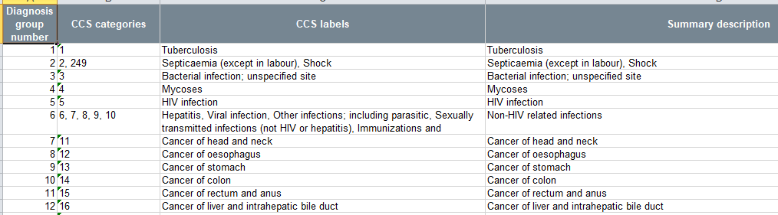

And then there is the main tab, with the actual data, e.g.:

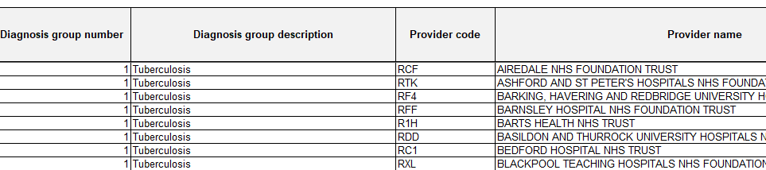

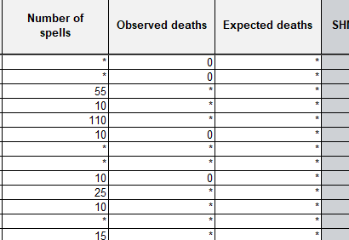

It’s a big sheet so had to split it above, and it’s another big file, 18,274 lines.

Now, I’m assuming that we’re to look at Observed Deaths, so we need to remember that there is a list we had previous, so posted it here again:

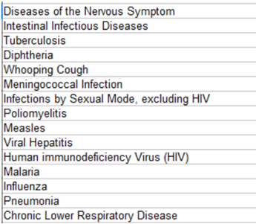

So, let’s see if we can match these up. I’m not going to look at which Trust (name of hospital and location), I’m just after the numbers. But you’re more than welcome to have a look yourself.

And the numbers I managed to find were startling. Now, please bear in mind that I’ve tried to find the same ‘causes’ as the WHO listings, and at some points, they lump certain causes together. Plus some I can’t fine, but they may not have them listed or in another group I couldn’t find.

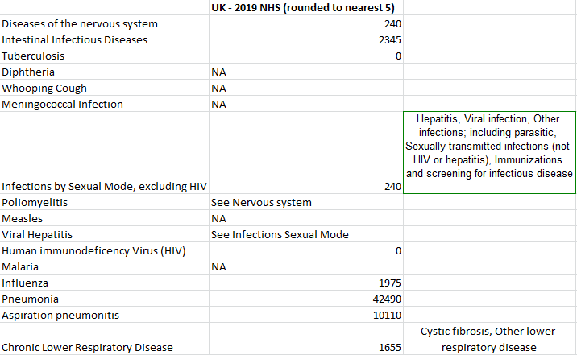

This is a list of all, in relation to each other.

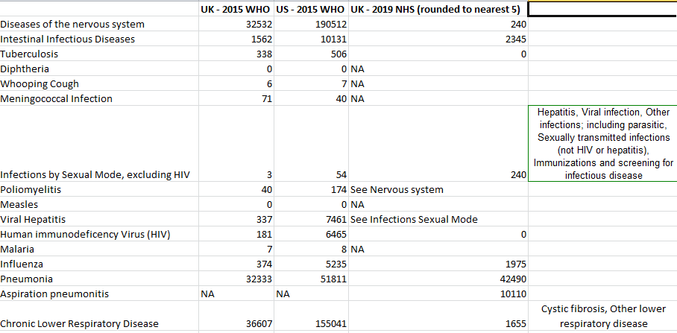

But in the meantime, let’s look at the UN.

Now, this is pretty daunting to say the least. Why? Well, it can have sections like probability of dying between birth and exact age 1 ☹

But, I’m just looking at the yearly data.

Main site:

<https://www.un.org/en/development/desa/population/theme/mortality/index.asp>

And I’m starting here:

<https://population.un.org/wpp/Download/Standard/Mortality/>

The one I’m looking at is “Number of deaths over a given period. Refers to five-year periods running from 1 July to 30 June of the initial and final years. Data are presented in thousands.”

A small snapshot:

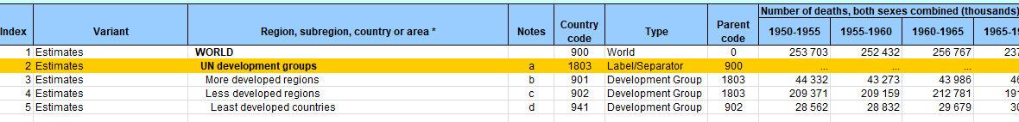

As usual with any of these, it’s a lot of delving through the lists.

The numbers that are shown in the above screenshot are in the thousands, so when it states say 908 deaths, it’s actually 908 x 1000 = 908,000.

When you take a look at the spreadsheet, there are many tabs. I’m just going to look at the Estimates tab. And when you look at the Region column, it even states if they’re a less developed region, high-income countries, or just each country on its own. Pretty daunting, but interesting no matter where you live.

Now, let’s take a look at the UK and US as we’ve been doing so far.

The year range will be 2015-2020, as they do them in 5’s:

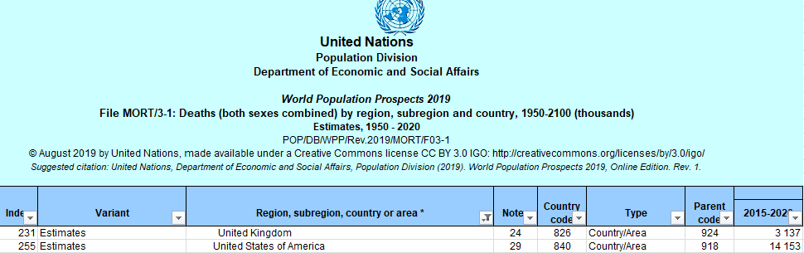

So, that is saying:

UK is 3,137,000

US is 14,153,000

So, this is where I will give my conclusions and overall thoughts.

Looking at the WHO database, in the years that we could obtain (2015), the amount of deaths for cases similar to Coronavirus (total) was:

UK - 104,391

US - 427,445

Using the ONS (UK only) for 2019, of which it can be for any cases the total was:

UK: 469,354

Using the NHS database (UK Only), in the year 2019, the amount of deaths for cases similar to Coronavirus (total) was:

UK: 59,055

Using the UN Database for 2015-2020, of which it can be for any cases the total, was:

UK: 3,137,000

US: 14,153,000

So, as you can see, depending on the year, and the database used, the numbers can vary. For instance, the WHO database was the most detailed, whereas the ONS was pretty basic. Plus not all had the most current numbers. This isn't as some will say, due to hiding the numbers, but probably due to actual obtaining them. Can you imagine the amount of records needed to exactly say which was what, for every single person, in every single country? It’s no wonder it will take a while.

So, because of this, we cannot draw a comparative assessment of the values, no matter where they're from. But what is definatly interesting is that when the MSN (Mainstream News) is stating that this is worse than anything, and in the country it’s been such and such deaths, just have a look at say the NHS database, and see that it’s a lot higher yearly. I have heard by some people that when their loved one dies by a fall, heart attack etc., they're being classed as covid-19, which skews the numbers.

Also, when people are being admitted to hospital with it, plus other issues, and die due to their lung giving up as they have lung cancer already, they're classed as covid.

Think of it another way. A person is involved in a car crash. Gets rushed to hospital with internal injuries. Surgery goes well, but then a day or so later, the person gets an infection or internal bleeding begins again on the spleen, and dies. Did he die from a car crash, or internal bleeding?

It’s obviously the latter, and that is why post mortems are carried out, to determine the cause of death in cases. It could have been a brain haemorrhage that caused it, but it’s the final thing that caused the person to die, not the interim.

I think this kind of research is pretty daunting to anyone, but I for some reason love getting to grips with the actuals stats and numbers. Look at the pay gap one, that took ages. But it’s the numbers you really need to see for yourself.

As always, thank you for reading and any comments, please post :)